**CODEGEN**

**A Project Report**

***Submitted by:***

**DHIREN SAHNI (04850118116)**

***in partial fulfilment for the award of the degree***

***of***

**BACHELOR OF VOCATION**

**IN**

**SOFTWARE DEVELOPMENT**

**at**



**INTEGRATED INSTITUTE OF TECHNOLOGY**

**DWARKA, SEC-9, NEW DELHI (INDIA) – 110079**

**(AFFILIATED TO GURU GOBIND SINGH INDRAPRASTHA UNIVERSITY, NEW DELHI (INDIA))**

**JUNE 2019**

**CODEGEN**

**A Project Report**

***Submitted by:***

**DHIREN SAHNI (04850118116)**

***in the partial fulfilment for the award of degree***

***of***

**BACHELOR OF VOCATION**

**IN**

**SOFTWARE DEVELOPMENT**

**at**



**INTEGRATED INSTITUTE OF TECHNOLOGY**

**DWARKA, SEC-9, NEW DELHI (INDIA) – 110079**

**(AFFILIATED TO GURU GOBIND SINGH INDRAPRASTHA UNIVERSITY, NEW DELHI (INDIA))**

**JUNE 2019**

**DECLARATION**

I hereby declare that the project entitled “CODEGEN” submitted for the B.Voc (SD) degree is my original work and the project has not formed the basis for the award of any other degree, diploma, fellowship or any other similar titles.

**Signature of the Student**

**Place:**

**Date:**

**CERTIFICATE**

This is to certify that the project titled “CODEGEN” is the bona fide work carried out by **Dhiren Sahni**, a student of B.Voc (SD) of Integrated Institute of Technology, Dwarka (New Delhi) affiliated to Guru Gobind Singh Indraprastha University, Dwarka, New Delhi(India) during the academic year 2018-19, in the partial fulfilment of the requirements for the award of the degree of Bachelor of Vocation (Software Development) and that the project has not formed the basis for the award previously of any other degree, diploma, fellowship or any other similar title.

**Signature of the Guide**

**Place:**

**Date:**

**ABSTRACT**

The main objective of this project is to develop an interactive website which manages training and placement activities in various fields of study easy with an interactive GUI where students can easily register themselves for either the training or placement drives. This website will benefit the students in many ways as it will provide students with all the necessary details and information about the current happenings and the upcoming events. Although such a project has a very wide scope, this project contains the most important part i.e. displaying the information regarding the trainings and placements. The students and professionals are provided with the facility of an app that allows students to keep a check on their attendance as well as the performance.

This project is aimed at developing a website for the training and placement company. The system is an interactive website that can be accessed throughout the company as well as outside the native state or country. The app facility can be used by the organization as an aid to manage the student information with regards to placement.

Company representatives can access/search any information put up by the students from the database.

The proposed project contains mainly modules, they are:

1. Home module
2. Courses module
3. Registration module
4. Enquiry module

**ACKNOWLWDGEMENT**

I express my sincere gratitude to Mr. Shashank Gupta (HOD), Mr. Inderjeet Yadav and Mrs. Damandeep Kaur for their valuable guidance and timely suggestions during the entire duration of my dissertation work, without which this work would not have been possible. I would also like to convey my deep regards to all other faculty members of NIELIT, who have bestowed their great effort and guidance at appropriate times without which it would have been very difficult on my part to finish this work. Finally, I would also like to thank my friends for their advice and pointing out my mistakes.

**Table of Content**

Title Page

Declaration of the Student………………………………………………...…....i

Certificate of the Guide………………………………………………………..ii

Abstract……………………………………………………………………….iii

Acknowledgement…………………………………………………………….iv

1. Introduction……………………………………………………………………1

1.1 Overview…………………………………………………………………..1

1.2 Purpose………………………………………………………………….....1

1.3 Scope………………………………………………………………………2

1.4 Functional components of the project……………………………………..2

1.5 More functionality can be added to “enhance the project”………………..2

1. System Analysis…………………………………………………………….....3

2.1 Present System…………………………………………………………….3

2.2 Proposed System…………………………………………………………..3

2.3 Benefits of the system……………………………………………………..3

1. Feasibility Report……………………………………………………………...4

3.1 Understanding Feasibility…………………………………………………4

3.2 Economical Feasibility…………………………………………………….4

3.3 Technical Feasibility………………………………………………………4

3.4 Behavioural Feasibility……………………………………………………4

1. Software Requirements & Specifications.…………………………………….5

4.1 Software required……………………………………………………….....5

4.2 Hardware required…………………………………………………………5

4.3 Software analysis report…………………………………………………...5

4.4 Technologies & requirements……………………………………………..6

1. System Design…………………………………………………………………7

5.1 Introduction………………………………………………………………..7

5.2 Database Table………………………………………………………….....8

1. Coding…………………………………………………………………………9
   1. CODEGEN website……………………………………………………….9
      1. Home………………………………………………………………9
      2. About Us…………………………………………………………13
      3. Services…………………………………………………………..15
      4. Placement assistance……………………………………………..17
      5. Facts ……………………………………………………………..17
      6. Courses…………………………………………………………...18
      7. Clients…………………………………………………………….32
      8. Training & Offerings……………………………………………..33
         1. Seminar……………………………………………………….33
         2. Certifications…………………………………………………35
         3. Training Project………………………………………………37
         4. Internship……………………………………………………..45
      9. Contact…………………………………………………………...49
         1. Contact Us……………………………………………………49
         2. Enquiry form…………………………………………………52
            1. insert.php……………………………………………..53
      10. Register Now……………………………………………………..55
          1. index.php……………………………………………..55
   2. CODEGEN App………………………………………………………….63
      1. activity_main.xml………………………………………………...63
      2. login.xml………..………………………………………………..64
      3. _listview_main.xml………………………………………………66
      4. add_attendance.xml………………………………………………66
      5. addfaculty.xml……………………………………………………70
      6. addstudent.xml…………………………………………………...75
      7. menu.xml…………………………………………………………80
      8. view_student.xml...………………………………………………82
      9. view_student_list.xml……………………………………………83
      10. view_faculty_list.xml…………………...………………………..83
      11. view_attendance_list_per_student.xml….……………………….83
      12. view_attendance_list.xml………………………………………...84
      13. test_main.xml……………………………………….……………85
      14. test_layout.xml…………………………………………………...85
      15. view_student.xml……………………………………………...…86
2. Screenshot……………………………………………………………………89
   1. Home Page…………………………………………………………….…89
   2. About Us…………………………………………………………………89
   3. Services…………………………………………………………………..89
   4. Placement assistance……………………………………………………..90
   5. Facts……………………………………………………………………...90
   6. Courses…………………………………………………………………...90
   7. Clients…………………………………………………………………….91
   8. Training & Offerings……………………………………………………..91

7.8.1 Seminar……………………………………………………………..91

7.8.2 Certifications……………………………………………………….92

7.8.3 Training Project…………………………………………………….92

7.8.4 Internship…………………………………………………………...92

* 1. Contact…………………………………………………………………...93

7.9.1 Contact Us………………………………………………………….93

7,9,2 Enquiry Form………………………………………………………93

* 1. Register Now…………………………………………………………94

1. System Testing and Implementation…………………………………………95
   1. Introduction ……………………………………………………………...95
   2. Strategic approach to Software Testing………………………………….95
   3. Unit Testing………………………………………………………………96
2. System Security………………………………………………………………98
   1. Introduction………………………………………………………………98
   2. Security in Software……………………………………………………...98
3. Conclusion…………………………………………………………………..100
4. Scope for Future Development……………………………………………...101
5. Bibliography………………………………………………………………...102
   1. For XAMPP installation…………………………………………….102
   2. For Android Studio installation……………………………………..102
   3. For Notepad++ installation………………………………………….102
   4. Reference websites………………………………………………….102
   5. Reference Books……………………………………………………102

**Introduction**

This project is aimed at developing a user-friendly website and App for students and working professionals. The system is an online support that can be accessed throughout the organization and outside as well as an application that updates the student/professional regarding his/her attendance and performance.

The project has been planned to be having the view of distributed architecture, with centralized storage of the database. The application for the storage of the data has been planned using the constructs of MySQL and all other user interfaces have been designed using HTML. The database connectivity is planned using the “Database” methodology. The standards of security and data protective mechanism have been given a big choice for proper usage. The application takes care of different modules and their associated reports, which are produced as per the applicable strategies and standards that are put forwarded by the administrative staff.

The entire project has been developed keeping in view of the distributed client server computing technology, in mind. The user interfaces are browser specific to give distributed accessibility for the overall system. The internal database has been selected as MySQL. The basic constructs of table spaces, clusters and indexes have been exploited to provide higher consistency and reliability for the data storage. The MySQL was a choice as it provides the constructs of high-level reliability and security. The total front end was dominated using the HTML 5. At all proper levels high care was taken to check that the system manages the data consistency with proper business rules or validations. The database connectivity was planned using the latest “Database connection” technology provided by MySQL. The authentication and authorization was cross checked at all the relevant stages.

* 1. **Overview**

This application makes an easy access to the training courses letting back home. It has an online registration option that help students to easily register with us. The idea of developing this website is to know more deeply about the growing web applications world with its features and working.

* 1. **Purpose**

Provide opportunity to apply the theoretical concept to actual situations. To explore the skills for gaining practical knowledge about real life situations.

To generate approach and confidence in problem solving. To equip with tools & techniques of gathering, selecting, sorting & analysing the information for relevant use in practice.

* 1. **Scope**

The Web Development project is widely applicable with public, private companies all over the world. It can even be used in organizations for them to easily display information publicly.

* 1. **Functional components of the project**

Following are the functional needs of the Website: -

1. Students/professionals enrolled must have valid ID and Password to login to the system (i.e. the app provided).
2. After the valid user logs in, the system shows the current information of that particular user.
3. Proper help to be provided as and when requested by the students/professionals.
   1. **More functionality can be added to “enhance the project”**
4. By adding new modules like User Login to let users login into their accounts to keep a record of their day to day work, performance, and events.
5. By the use of Digital Marketing tools, the website can be advertised more on various platforms.

**System Analysis**

* 1. **Present System**

The developed website is an innovation in the area of private organizations. In the existing system the number of staff required for completing the work is more, while the new system requires lesser staff.

The data entry process requires the data on the paper, which is then fed into the database application by the operator while doing so, the data entry operator has to look into the paper again and again and thus the chances of inaccuracies in the typed contents increases. Also the process includes higher transportation cost, increased handling cost, more time delays, low accuracy, more usage of resources like registers, books, papers etc.

* 1. **Proposed System**

“Why an automated data entry method for registrations?”

* Almost 60% of todays information is still paper based.
* 30% of all office time is spent finding documents.
* The average time to manage a single document is 12 minutes.
* 9 minutes to re-file and 3 minutes to process.

Hence the requirement is to develop a system that minimizes all these overheads included while giving the maximum output for the organization.

The basis for the project is to develop a fully automated website and an online attendance management system that includes student registration, student information, inquiry facility and exporting the current information back to the users while considering all the tools and facilities than a client may need for efficient and effective output.

* 1. **Benefits of the system**
* Quick online registration for the far-off students/professionals.
* Easily scalable to grow with changing system requirement.
* Enterprise wide access to information, improved information quality.
* Restricting unauthorized access and minimize storage space

**Feasibility Report**

* 1. **Understanding Feasibility**

Feasibility study means the analysis of problem to determine if, it can be solved effectively. In other words, it is the study of the possibilities of the proposed system it studies the work ability, impact on the organization ability to meet user’s need and efficient use of resources.

Three aspects in which the system has to be feasible are: -

* 1. **Economical Feasibility**

The economical analysis checks for the high investment incurred on the system. It evaluates development & implementing charges for the proposed “Web Development Project”. The Software used for the development is easily available at minimal cost & the database applied is freely available hence it results in low cost implementation.

* 1. **Technical Feasibility**

This aspect concentrates on the concept of using Computer Meaning, “Mechanization” of human works. Thus, the automated solution leads to the need for a technical feasibility study.

The focus on the platform used database management & users for that Software.

The proposed system doesn’t require an in-depth technical knowledge as the system development is simple and easy to understand. The Software used makes the system user friendly (GUI). The result obtain should be true in the real time conditions.

* 1. **Behavioural Feasibility**

Behavioural feasibility deals with the runtime performance of the Software the proposed system must score higher than the present in the behavioural study. The Software should have end user in mind when the system is designed while designing Software the programmer should be aware of the conditions user’s Knowledge input, output, calculations etc.

**Software Requirements & Specifications**

**4.1 Software Required:**

The project is implemented in HTML.

* **Operating system:** Windows or Linux or Mac
* **User Interface:** HTML, PHP
* **Programming Language:** HTML
* **Database:** MySQL
* **Web Server:** Apache

**4.2 Hardware Required:**

* **Processor:** P2 or above with Intel Architecture
* **Hard Disk:** 10 GB minimum
* **RAM:** 256 MB or more

**4.3 Software Analysis Report**

**4.3.1 Features of XAMPP**

* XAMPP Apache Server includes Apache MySQL and PHP for Windows.
* It is a free tool to configure a local server on your personal machine.
* Most popular development environment for PHP.
* XAMPP is a free tool for developers when developing database-driven PHP projects.
* Easy Apache Configuration.
* Support for Tomcat server
* Comes up with manual and automatic configurations
* No technical knowledge required to install and configure XAMPP Server
* Easy to run PHP on local server
* User-friendly interface
* FTP FileZilla included is a basic feature
* Run any server with just one click
* Support for Mercury
* Most Reliable tool
* Multi-lingual development Environment

**4.4 Technologies and Requirements**

* **IDE:**

Notepad++

* **Front End:**

HTML, CSS, JavaScript, Bootstrap, jQuery

* **Programming Language:**

HTML

* **Back End:**

PHP

* **Server:**

XAMPP Apache

**System Design**

**5.1 Introduction**

Software design sits at the technical kernel of the Software engineering process and is applied regardless of the development paradigm and area of application. Design is the first step in the development phase for any engineered product or system. The designer’s goal is to produce a model or representation of an entity that will later be built. Beginning, once system requirement has been specified and analysed, system design is the first of the three technical activities -design, code and test that is required to build and verify Software.

The importance can be stated with a single word “Quality”. Design is the place where quality is fostered in Software development. Design provides us with representations of Software that can assess for quality. Design is the only way that we can accurately translate a customer’s view into a finished Software product or system. Software design serves as a foundation for all the Software engineering steps that follow. Without a strong design we risk building an unstable system – one that will be difficult to test, one whose quality cannot be assessed until the last stage.

During design, progressive refinement of data structure, program structure, and procedural details are developed reviewed and documented. System design can be viewed from either technical or project management perspective. From the technical point of view, design is comprised of four activities – architectural design, data structure design, interface design and procedural design.

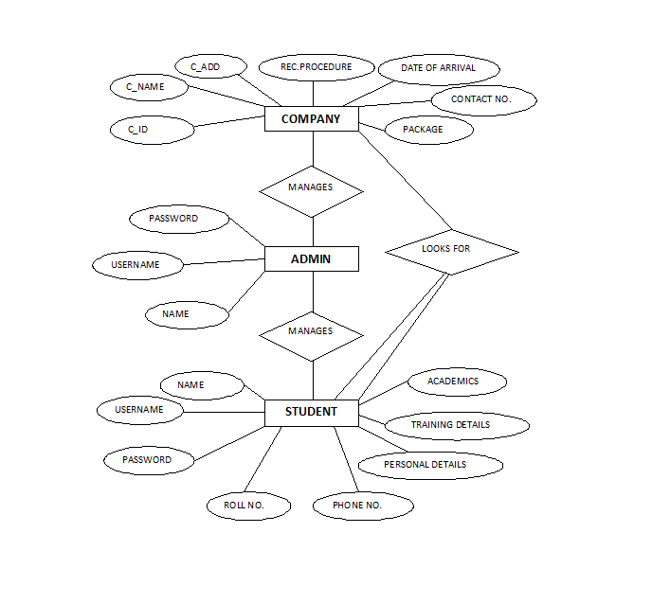

**5.2 Database Table:**

**Coding**

**6.1 CODEGEN Website**

**6.1.1 Home:**

<header id="header">

<div class="container-fluid">

<div id="logo" class="pull-left">

<a href="#intro"><img src="img/logo1.png" alt="logo" title="" /></a>

</div>

<nav id="nav-menu-container">

<ul class="nav-menu">

<li class="menu-active"><a href="#intro">Home</a></li>

<li><a href="#about">About Us</a></li>

<li><a href="#services">Services</a></li>

<li><a href="#portfolio">Courses</a></li>

<li class="menu-has-children"><a href="">Training Offerings</a>

<ul>

<li><a href="training&offerings/training&offerings.html#Seminar">Seminar</a></li>

<li><a href="training&offerings/training&offerings.html#Certifications">Certifications</a></li>

<li><a href="training&offerings/training&offerings.html#TrainingProject">Training Project</a></li>

<li><a href="training&offerings/training&offerings.html#Internship">Internship</a></li>

</ul>

</li>

<ul>

<li><a href="#">News & Events</a></li>

<li><a href="#">Industry News</a></li>

</ul>

</li>-->

<li><a href="#contact">Contact</a></li>

<li><a href="colorlib-regform-15/colorlib-regform-15/index.php">Register Now</a></li>

</ul>

</nav><!-- #nav-menu-container -->

</div>

</header>

<section id="intro">

<div class="intro-container">

<div id="introCarousel" class="carousel slide carousel-fade" data-ride="carousel">

<ol class="carousel-indicators"></ol>

<div class="carousel-inner" role="listbox">

<div class="carousel-item active">

<div class="carousel-background"><img src="img/intro-carousel/1.jpg" alt=""></div>

<div class="carousel-container">

<div class="carousel-content">

<h2>We are professional</h2>

<p>Be Stubborn About Your Goals & Flexible About Your Methods</p>

<a href="#about" class="btn-get-started scrollto">Get Started</a>

</div>

</div>

</div>

<div class="carousel-item">

<div class="carousel-background"><img src="img/intro-carousel/2.png" alt=""></div>

<div class="carousel-container">

<div class="carousel-content">

<h2>Training</h2>

<p>Training is specific to the IT industry, or to the skills necessary for performing information technology jobs.</p>

<a href="#portfolio" class="btn-get-started scrollto">Get Started</a>

</div>

</div>

</div>

<div class="carousel-item">

<div class="carousel-background"><img src="img/intro-carousel/3.png" alt=""></div>

<div class="carousel-container">

<div class="carousel-content">

<h2>Certifications</h2>

<p>Best in class certifications are provided from renowned companies.</p>

</div>

</div>

</div>

<div class="carousel-item">

<div class="carousel-background"><img src="img/intro-carousel/4.jpg" alt=""></div>

<div class="carousel-container">

<div class="carousel-content">

<h2>Courses</h2>

<p>Information Technology now lies at the heart of almost every business and every organization across the globe.By studying IT courses at CODEGEN you will gain valuable, technical and theoretical knowledge and qualifications.</p>

<a href="#portfolio" class="btn-get-started scrollto">Get Started</a>

</div>

</div>

</div>

<div class="carousel-item">

<div class="carousel-background"><img src="img/intro-carousel/5.png" alt=""></div>

<div class="carousel-container">

<div class="carousel-content">

<h2>Your Dream Job</h2>

<p>Finding a job that you love is now possible with CODEGEN which provides a gateway to further studies or a rewarding career in a host of associated disciplines.</p>

<a href="#call-to-action" class="btn-get-started scrollto">Get Started</a>

</div>

</div>

</div>

</div>

<a class="carousel-control-prev" href="#introCarousel" role="button" data-slide="prev">

<span class="carousel-control-prev-icon ion-chevron-left" aria-hidden="true"></span>

<span class="sr-only">Previous</span>

</a>

<a class="carousel-control-next" href="#introCarousel" role="button" data-slide="next">

<span class="carousel-control-next-icon ion-chevron-right" aria-hidden="true"></span>

<span class="sr-only">Next</span>

</a>

</div>

</div>

</section>

**6.1.2 About Us:**

<section id="about">

<div class="container">

<header class="section-header">

<h3>About Us</h3>

<p>CODEGEN is the leader in the “specialized training” brands of India certified by ISO 9001:2015 for its best quality. CODEGEN is the largest training service provider in various IT domains for all IT students as well as for the working professionals. It has an extensive experience of nurturing over 200000+ students in the past few years. CODEGEN has been awarded as the “Best IT and Embedded Training Company” for 5 consecutive years for delivering high quality training and workshops at more than 500 colleges across World. CODEGEN is a trustworthy brand in Education and Training industry with its presence across several cities such as Noida, Roorkee, Lucknow and Dehradun. The company was started 12 years back and it is continuously expanding having its overseas branches in New York, Germany and Ukraine.</p>

</header>

<div class="row about-cols">

<div class="col-md-4 wow fadeInUp">

<div class="about-col">

<div class="img">

<img src="img/about-mission.jpg" alt="" class="img-fluid">

<div class="icon"><i class="ion-ios-speedometer-outline"></i></div>

</div>

<h2 class="title">Our Mission</h2>

<p>

Motivate. Inspire. Learning and development contributes to the success of organization by partnering with Microsoft, IBM, Oracle, Adobe, VMWare, AWS, Cybereason associates and leaders to drive learning that is strategic , measurable and effective.

</p>

</div>

</div>

<div class="col-md-4 wow fadeInUp" data-wow-delay="0.1s">

<div class="about-col">

<div class="img">

<img src="img/about-plan.jpg" alt="" class="img-fluid">

<div class="icon"><i class="ion-ios-list-outline"></i></div>

</div>

<h2 class="title">Our Belief</h2>

<p>

Everybody has got talent, passion & a leader in them.We just need to train and coach them to emerge them as winners in all spheres of life. "Expound the actual teachings of the great truth and the master-builder of human happiness."

</p>

</div>

</div>

<div class="col-md-4 wow fadeInUp" data-wow-delay="0.2s">

<div class="about-col">

<div class="img">

<img src="img/about-vision.jpg" alt="" class="img-fluid">

<div class="icon"><i class="ion-ios-eye-outline"></i></div>

</div>

<h2 class="title">Our Vision</h2>

<p>

Our efforts are focused on bringing out the best within every individual and epitomizing their capacity to unprecedented levels.Emerging as an acclaimed body for setting training & development standards in India & worldwide.

</p>

</div>

</div>

</div>

</div>

</section>

**6.1.3 Services:**

<section id="services">

<div class="container">

<header class="section-header wow fadeInUp">

<h3>Services</h3>

</header>

<div class="row">

<div class="col-lg-4 col-md-6 box wow bounceInUp" data-wow-duration="1.4s">

<h4 class="title">2/3/4 weeks</h4>

<p class="description">C/C++ , Java , Python , Basic HTML & CSS , Javascript , XML</p>

</div>

<div class="col-lg-4 col-md-6 box wow bounceInUp" data-wow-duration="1.4s">

<h4 class="title">6 weeks</h4>

<p class="description">Web Development & Designing , Ethical Hacking , PHP , Linux , Graphical Designing </p>

</div>

<div class="col-lg-4 col-md-6 box wow bounceInUp" data-wow-duration="1.4s">

<h4 class="title">Short Term</h4>

<p class="description">.Net , ASP.Net with C# , Angular JS , Backbone JS , MS-Office </p>

</div>

<div class="col-lg-4 col-md-6 box wow bounceInUp" data-wow-delay="0.1s" data-wow-duration="1.4s">

<h4 class="title">Long Term</h4>

<p class="description">All courses are provided with projects for a duration of 6 months.</p>

</div>

<div class="col-lg-4 col-md-6 box wow bounceInUp" data-wow-delay="0.1s" data-wow-duration="1.4s">

<h4 class="title">Overseas & Online Training</h4>

<p class="description"> CODEGEN overseas training agenda is one suitable method of communication of latest technologies and courses which are demanded in the market.</p>

</div>

<div class="col-lg-4 col-md-6 box wow bounceInUp" data-wow-delay="0.1s" data-wow-duration="1.4s">

<h4 class="title">College campus training</h4>

<p class="description">College campus training program is a manifesto for providing complete training for engineering students on latest technologies to college students from different areas like B.Tech/M.Tech, B.Sc/M.Sc, BCA/MCA, etc. within college campus itself.</p>

</div>

</div>

</div>

</section>

**6.1.4 Placement assistance**

<section id="call-to-action" class="wow fadeIn">

<div class="container text-center">

<h3>Placement Assistance</h3>

<p>Apart from technical training in various software & hands-on project work, CODEGEN helps you get a foothold in the booming IT industry.The institute regularly conducts placement workshops to prepare students to face job interviews & aptitude tests. Students are taught skills like resume writing, presentation skills & time management, etc in these workshops so that they become completely industry-ready by the time they complete their course.</p>

<a class="cta-btn" href="#contact">Placement Enquiries..</a>

</div>

</section>

**6.1.5 Facts**

<section id="facts" class="wow fadeIn">

<div class="container">

<header class="section-header">

<h3>Facts</h3>

</header>

<div class="row counters">

<div class="col-lg-3 col-6 text-center">

<span data-toggle="counter-up">274</span>

<p>Clients</p>

</div>

<div class="col-lg-3 col-6 text-center">

<span data-toggle="counter-up">421</span>

<p>Projects</p>

</div>

<div class="col-lg-3 col-6 text-center">

<span data-toggle="counter-up">1,364</span>

<p>Hours Of Support</p>

</div>

<div class="col-lg-3 col-6 text-center">

<span data-toggle="counter-up">18</span>

<p>Hard Workers</p>

</div>

</div>

<div class="facts-img">

<img src="img/fact-img.png" alt="" class="img-fluid">

</div>

</div>

</section>

**6.1.6 Courses**

<section id="portfolio" class="section-bg" >

<div class="container">

<header class="section-header">

<h3 class="section-title">Our Courses</h3>

</header>

<div class="row">

<div class="col-lg-12">

<ul id="portfolio-flters">

<li data-filter="*" class="filter-active">All</li>

<li data-filter=".filter-language">Languages</li>

<li data-filter=".filter-graphics">Graphics</li>

<li data-filter=".filter-web">Web</li>

<li data-filter=".filter-other">Others</li>

</ul>

</div>

</div>

<div class="row portfolio-container">

<div class="col-lg-4 col-md-6 portfolio-item filter-language wow fadeInUp">

<div class="portfolio-wrap">

<figure>

<img src="img/portfolio/c-and-c++.jpg" class="img-fluid" alt="">

<a href="img/portfolio/c-and-c++.jpg" data-lightbox="portfolio" data-title="App 1" class="link-preview" title="Preview"><i class="ion ion-eye"></i></a>

<a href="Courselist/Language.html#Cplus" class="link-details" title="More Details"><i class="ion ion-android-open"></i></a>

</figure>

<div class="portfolio-info">

<h4><a href="Courselist/Language.html#Cplus">C/C++</a></h4>

<p>Language</p>

</div>

</div>

</div>

<div class="col-lg-4 col-md-6 portfolio-item filter-language wow fadeInUp" data-wow-delay="0.1s">

<div class="portfolio-wrap">

<figure>

<img src="img/portfolio/java.jpg" class="img-fluid" alt="">

<a href="img/portfolio/java.jpg" class="link-preview" data-lightbox="portfolio" data-title="Web 3" title="Preview"><i class="ion ion-eye"></i></a>

<a href="Courselist/Language.html#Java" class="link-details" title="More Details"><i class="ion ion-android-open"></i></a>

</figure>

<div class="portfolio-info">

<h4><a href="Courselist/Language.html#Java">Java</a></h4>

<p>Language</p>

</div>

</div>

</div>

<div class="col-lg-4 col-md-6 portfolio-item filter-language wow fadeInUp" data-wow-delay="0.2s">

<div class="portfolio-wrap">

<figure>

<img src="img/portfolio/python.png" class="img-fluid" alt="">

<a href="img/portfolio/python.png" class="link-preview" data-lightbox="portfolio" data-title="App 2" title="Preview"><i class="ion ion-eye"></i></a>

<a href="Courselist/Language.html#Python" class="link-details" title="More Details"><i class="ion ion-android-open"></i></a>

</figure>

<div class="portfolio-info">

<h4><a href="Courselist/Language.html#Python">Python</a></h4>

<p>Language</p>

</div>

</div>

</div>

<div class="col-lg-4 col-md-6 portfolio-item filter-language wow fadeInUp">

<div class="portfolio-wrap">

<figure>

<img src="img/portfolio/php.png" class="img-fluid" alt="">

<a href="img/portfolio/php.png" class="link-preview" data-lightbox="portfolio" data-title="Card 2" title="Preview"><i class="ion ion-eye"></i></a>

<a href="Courselist/Language.html#Php" class="link-details" title="More Details"><i class="ion ion-android-open"></i></a>

</figure>

<div class="portfolio-info">

<h4><a href="Courselist/Language.html#Php">PHP</a></h4>

<p>Language</p>

</div>

</div>

</div>

<div class="col-lg-4 col-md-6 portfolio-item filter-language wow fadeInUp" data-wow-delay="0.1s">

<div class="portfolio-wrap">

<figure>

<img src="img/portfolio/csharp.jpg" class="img-fluid" alt="">

<a href="img/portfolio/csharp.jpg" class="link-preview" data-lightbox="portfolio" data-title="Web 2" title="Preview"><i class="ion ion-eye"></i></a>

<a href="Courselist/Language.html#Csharp" class="link-details" title="More Details"><i class="ion ion-android-open"></i></a>

</figure>

<div class="portfolio-info">

<h4><a href="Courselist/Language.html#Csharp">C#</a></h4>

<p>Language</p>

</div>

</div>

</div>

<div class="col-lg-4 col-md-6 portfolio-item filter-language wow fadeInUp" data-wow-delay="0.2s">

<div class="portfolio-wrap">

<figure>

<img src="img/portfolio/xml-tutorial.png" class="img-fluid" alt="">

<a href="img/portfolio/xml-tutorial.png" class="link-preview" data-lightbox="portfolio" data-title="App 3" title="Preview"><i class="ion ion-eye"></i></a>

<a href="Courselist/Language.html#Xml" class="link-details" title="More Details"><i class="ion ion-android-open"></i></a>

</figure>

<div class="portfolio-info">

<h4><a href="Courselist/Language.html#Xml">XML</a></h4>

<p>Language</p>

</div>

</div>

</div>

<div class="col-lg-4 col-md-6 portfolio-item filter-language wow fadeInUp">

<div class="portfolio-wrap">

<figure>

<img src="img/portfolio/AngulasJs.png" class="img-fluid" alt="">

<a href="img/portfolio/AngulasJs.png" class="link-preview" data-lightbox="portfolio" data-title="Card 1" title="Preview"><i class="ion ion-eye"></i></a>

<a href="Courselist/Language.html#AngularJs" class="link-details" title="More Details"><i class="ion ion-android-open"></i></a>

</figure>

<div class="portfolio-info">

<h4><a href="Courselist/Language.html#Angularjs">Angular JS</a></h4>

<p>Language</p>

</div>

</div>

</div>

<div class="col-lg-4 col-md-6 portfolio-item filter-language wow fadeInUp" data-wow-delay="0.1s">

<div class="portfolio-wrap">

<figure>

<img src="img/portfolio/backbone.png" class="img-fluid" alt="">

<a href="img/portfolio/backbone.png" class="link-preview" data-lightbox="portfolio" data-title="Card 3" title="Preview"><i class="ion ion-eye"></i></a>

<a href="Courselist/Language.html#Backbonejs" class="link-details" title="More Details"><i class="ion ion-android-open"></i></a>

</figure>

<div class="portfolio-info">

<h4><a href="Courselist/Language.html#Backbonejs">Backbone JS</a></h4>

<p>Language</p>

</div>

</div>

</div>

<div class="col-lg-4 col-md-6 portfolio-item filter-web wow fadeInUp" data-wow-delay="0.2s">

<div class="portfolio-wrap">

<figure>

<img src="img/portfolio/htmlcssjs.jpeg" class="img-fluid" alt="">

<a href="img/portfolio/htmlcssjs.jpeg" class="link-preview" data-lightbox="portfolio" data-title="Web 1" title="Preview"><i class="ion ion-eye"></i></a>

<a href="Courselist/Web.html#Htmljscss" class="link-details" title="More Details"><i class="ion ion-android-open"></i></a>

</figure>

<div class="portfolio-info">

<h4><a href="Courselist/Web.html#Htmljscss">HTML/CSS/JS</a></h4>

<p>Web</p>

</div>

</div>

</div>

<div class="col-lg-4 col-md-6 portfolio-item filter-web wow fadeInUp" data-wow-delay="0.2s">

<div class="portfolio-wrap">

<figure>

<img src="img/portfolio/dotnet.jpg" class="img-fluid" alt="">

<a href="img/portfolio/dotnet.jpg" class="link-preview" data-lightbox="portfolio" data-title="Web 1" title="Preview"><i class="ion ion-eye"></i></a>

<a href="Courselist/Web.html#Dotnet" class="link-details" title="More Details"><i class="ion ion-android-open"></i></a>

</figure>

<div class="portfolio-info">

<h4><a href="Courselist/Web.html#Dotnet">.NET</a></h4>

<p>Web</p>

</div>

</div>

</div>

<div class="col-lg-4 col-md-6 portfolio-item filter-web wow fadeInUp" data-wow-delay="0.2s">

<div class="portfolio-wrap">

<figure>

<img src="img/portfolio/Visual_Basic.png" class="img-fluid" alt="">

<a href="img/portfolio/Visual_Basic.png" class="link-preview" data-lightbox="portfolio" data-title="Web 1" title="Preview"><i class="ion ion-eye"></i></a>

<a href="Courselist/Web.html#Visualbasic" class="link-details" title="More Details"><i class="ion ion-android-open"></i></a>

</figure>

<div class="portfolio-info">

<h4><a href="Courselist/Web.html#Visualbasic">Visual Basics</a></h4>

<p>Web</p>

</div>

</div>

</div>

<div class="col-lg-4 col-md-6 portfolio-item filter-web wow fadeInUp" data-wow-delay="0.2s">

<div class="portfolio-wrap">

<figure>

<img src="img/portfolio/asp_net.jpg" class="img-fluid" alt="">

<a href="img/portfolio/asp_net.jpg" class="link-preview" data-lightbox="portfolio" data-title="Web 1" title="Preview"><i class="ion ion-eye"></i></a>

<a href="Courselist/Web.html#Asp" class="link-details" title="More Details"><i class="ion ion-android-open"></i></a>

</figure>

<div class="portfolio-info">

<h4><a href="Courselist/Web.html#Asp">ASP</a></h4>

<p>Web</p>

</div>

</div>

</div>

<div class="col-lg-4 col-md-6 portfolio-item filter-graphics wow fadeInUp" data-wow-delay="0.2s">

<div class="portfolio-wrap">

<figure>

<img src="img/portfolio/corel.png" class="img-fluid" alt="">

<a href="img/portfolio/corel.png" class="link-preview" data-lightbox="portfolio" data-title="Web 1" title="Preview"><i class="ion ion-eye"></i></a>

<a href="Courselist/Graphic.html#Corel" class="link-details" title="More Details"><i class="ion ion-android-open"></i></a>

</figure>

<div class="portfolio-info">

<h4><a href="Courselist/Graphic.html#Corel">Corel Draw</a></h4>

<p>Graphic</p>

</div>

</div>

</div>

<div class="col-lg-4 col-md-6 portfolio-item filter-graphics wow fadeInUp" data-wow-delay="0.2s">

<div class="portfolio-wrap">

<figure>

<img src="img/portfolio/adobe-flash.jpg" class="img-fluid" alt="">

<a href="img/portfolio/adobe-flash.jpg" class="link-preview" data-lightbox="portfolio" data-title="Web 1" title="Preview"><i class="ion ion-eye"></i></a>

<a href="Courselist/Graphic.html#Flash" class="link-details" title="More Details"><i class="ion ion-android-open"></i></a>

</figure>

<div class="portfolio-info">

<h4><a href="Courselist/Graphic.html#Flash">Flash</a></h4>

<p>Graphic</p>

</div>

</div>

</div>

<div class="col-lg-4 col-md-6 portfolio-item filter-graphics wow fadeInUp" data-wow-delay="0.2s">

<div class="portfolio-wrap">

<figure>

<img src="img/portfolio/Photoshop.png" class="img-fluid" alt="">

<a href="img/portfolio/Photoshop.png" class="link-preview" data-lightbox="portfolio" data-title="Web 1" title="Preview"><i class="ion ion-eye"></i></a>

<a href="Courselist/Graphic.html#Photoshop" class="link-details" title="More Details"><i class="ion ion-android-open"></i></a>

</figure>

<div class="portfolio-info">

<h4><a href="Courselist/Graphic.html#Photoshop">Photoshop</a></h4>

<p>Graphic</p>

</div>

</div>

</div>

<div class="col-lg-4 col-md-6 portfolio-item filter-graphics wow fadeInUp" data-wow-delay="0.2s">

<div class="portfolio-wrap">

<figure>

<img src="img/portfolio/pagemaker.jpg" class="img-fluid" alt="">

<a href="img/portfolio/pagemaker.jpg" class="link-preview" data-lightbox="portfolio" data-title="Web 1" title="Preview"><i class="ion ion-eye"></i></a>

<a href="Courselist/Graphic.html#Pmaker" class="link-details" title="More Details"><i class="ion ion-android-open"></i></a>

</figure>

<div class="portfolio-info">

<h4><a href="Courselist/Graphic.html#Pmaker">PageMaker</a></h4>

<p>Graphic</p>

</div>

</div>

</div>

<div class="col-lg-4 col-md-6 portfolio-item filter-other wow fadeInUp" data-wow-delay="0.2s">

<div class="portfolio-wrap">

<figure>

<img src="img/portfolio/android.jpg" class="img-fluid" alt="">

<a href="img/portfolio/android.jpg" class="link-preview" data-lightbox="portfolio" data-title="Web 1" title="Preview"><i class="ion ion-eye"></i></a>

<a href="Courselist/Other.html#Android" class="link-details" title="More Details"><i class="ion ion-android-open"></i></a>

</figure>

<div class="portfolio-info">

<h4><a href="Courselist/Other.html#Android">Android</a></h4>

<p>Others</p>

</div>

</div>

</div>

<div class="col-lg-4 col-md-6 portfolio-item filter-other wow fadeInUp" data-wow-delay="0.2s">

<div class="portfolio-wrap">

<figure>

<img src="img/portfolio/msoffice.jpg" class="img-fluid" alt="">

<a href="img/portfolio/msoffice.jpg" class="link-preview" data-lightbox="portfolio" data-title="Web 1" title="Preview"><i class="ion ion-eye"></i></a>

<a href="Courselist/Other.html#Office" class="link-details" title="More Details"><i class="ion ion-android-open"></i></a>

</figure>

<div class="portfolio-info">

<h4><a href="Courselist/Other.html#Office">MS-Office</a></h4>

<p>Others</p>

</div>

</div>

</div>

<div class="col-lg-4 col-md-6 portfolio-item filter-other wow fadeInUp" data-wow-delay="0.2s">

<div class="portfolio-wrap">

<figure>

<img src="img/portfolio/SQLServer.png" class="img-fluid" alt="">

<a href="img/portfolio/SQLServer.png" class="link-preview" data-lightbox="portfolio" data-title="Web 1" title="Preview"><i class="ion ion-eye"></i></a>

<a href="Courselist/Other.html#Server" class="link-details" title="More Details"><i class="ion ion-android-open"></i></a>

</figure>

<div class="portfolio-info">

<h4><a href="Courselist/Other.html#Server">SQL Server</a></h4>

<p>Others</p>

</div>

</div>

</div>

<div class="col-lg-4 col-md-6 portfolio-item filter-other wow fadeInUp" data-wow-delay="0.2s">

<div class="portfolio-wrap">

<figure>

<img src="img/portfolio/MySQL.png" class="img-fluid" alt="">

<a href="img/portfolio/MySQL.png" class="link-preview" data-lightbox="portfolio" data-title="Web 1" title="Preview"><i class="ion ion-eye"></i></a>

<a href="Courselist/Other.html#Mysql" class="link-details" title="More Details"><i class="ion ion-android-open"></i></a>

</figure>

<div class="portfolio-info">

<h4><a href="Courselist/Other.html#Mysql">MySQL</a></h4>

<p>Others</p>

</div>

</div>

</div>

<div class="col-lg-4 col-md-6 portfolio-item filter-other wow fadeInUp" data-wow-delay="0.2s">

<div class="portfolio-wrap">

<figure>

<img src="img/portfolio/linux.png" class="img-fluid" alt="">

<a href="img/portfolio/linux.png" class="link-preview" data-lightbox="portfolio" data-title="Web 1" title="Preview"><i class="ion ion-eye"></i></a>

<a href="Courselist/Other.html#Linux" class="link-details" title="More Details"><i class="ion ion-android-open"></i></a>

</figure>

<div class="portfolio-info">

<h4><a href="Courselist/Other.html#Linux">Linux</a></h4>

<p>Others</p>

</div>

</div>

</div>

<div class="col-lg-4 col-md-6 portfolio-item filter-other wow fadeInUp" data-wow-delay="0.2s">

<div class="portfolio-wrap">

<figure>

<img src="img/portfolio/ethical-hacking.jpg" class="img-fluid" alt="">

<a href="img/portfolio/ethical-hacking.jpg" class="link-preview" data-lightbox="portfolio" data-title="Web 1" title="Preview"><i class="ion ion-eye"></i></a>

<a href="Courselist/Other.html#Hacking" class="link-details" title="More Details"><i class="ion ion-android-open"></i></a>

</figure>

<div class="portfolio-info">

<h4><a href="Courselist/Other.html#Hacking">Ethical Hacking</a></h4>

<p>Others</p>

</div>

</div>

</div>

</div>

</div>

</section>

**6.1.7 Clients**

<section id="clients" class="wow fadeInUp">

<div class="container">

<header class="section-header">

<h3>Our Clients</h3>

</header>

<div class="owl-carousel clients-carousel">

<img src="img/clients/client-1.png" alt="">

<img src="img/clients/client-2.png" alt="">

<img src="img/clients/client-3.png" alt="">

<img src="img/clients/client-4.png" alt="">

<img src="img/clients/client-5.png" alt="">

<img src="img/clients/client-6.png" alt="">

<img src="img/clients/client-7.png" alt="">

<img src="img/clients/client-8.png" alt="">

</div>

</div>

</section>

**6.1.8 Training & Offerings**

**6.1.8.1 Seminar**

<body data-spy="scroll" data-target="#myScrollspy" data-offset="20">

<div class="container">

<div class="row">

<nav class="col-sm-3" id="myScrollspy">

<ul class="nav nav-pills nav-stacked">

<a href="#intro"><img src="logo1.png" alt="logo" /></a>

<li><a href="#Seminar">Seminar</a></li>

<li><a href="#Certifications">Certifications</a></li>

<li><a href="#TrainingProject">Training Project</a></li>

<li><a href="#Internship">Internship</a></li>

</ul>

</nav>

<div class="paragraphs">

<div id="Seminar">

<h1>Seminar</h1>

<div class="row">

<div class="span4">

<img style="float:left" src="eprivacy.png"/>

<p>Seminars are a monthly affair through which we organize various campaigns and promotions for the colleges and schools, bringing that extra edge to the institute which helps in increasing the brand positioning of the college in the academic world. Our seminars have become a sought after brand and we continually receive offers from institutions to deliver in their campuses.</p>

<div class="span4">

<h3>Overview</h3>

<p>The objective of seminars is to educate the college or the institute about the nitty- gritty of Ethical Hacking and Information Security through well-refined and searched materials. Major emphasis is put upon the core concepts and its applications. Our speakers are trained and professional faculty members, who are the champions in their trade and cover all the topics with great diligence and accuracy. The main focus of such activities is to impart as much knowledge and information about Ethical Hacking and IT security to the enthusiastic students who are keen learners and listeners. These seminars are entirely free of cost and cater to the technical graduates and industry beginners.</p>

<h3>Be a part of Information Security Campaign</h3>

<p>To encourage audience to be part of Information Security Campaign, CODEGEN has launched following series for organization all across India:</p>

<ul>

<li >e-Privacy - Foundation of Information Security</li>

<li>e-Privacy - An Eye Opener to Cyber Social Media Security</li>

<li>e-Privacy - Introduction to Computer Security</li>

<li>e-Privacy - Principles of Cyber Forensics</li>

</ul>

<h3>What we cover or why such seminars are conducted or why should you attend</h3>

<p>Let's accept that in the world of greater digital dependency, the digital crime also catches up, and many a times our seemingly secure data is malignantly accessed and manipulated by the unscrupulous elements. Information security is the prime concern of any office. Sensitive information must be protected from any malicious attack from the perpetrators.</p>

<p>Not only at the macro level, even at the micro level, it becomes extremely important to maintain a high degree of safety in our dealings with the internet. There have been all kind of cases, ranging from credit card fraud to bank account fraud, from public profiles being hacked to mail accounts being abused. So, it is necessary for everyone to adopt enough security measures that would thwart any such attacks and make their data impeccably safe and secure.</p>

<p>Computer Security is indeed an issue of global concern. It is our responsibility to be prepared against any malicious virus or hacking attack. And this course gives the right insights on how to do that. We prepare you to understand the modus operandi of the hackers and viruses and hence help you develop innovative and ingenious ways to fight this menace.</p>

<p>With enough expertise of our trainers and recent state of the art technologies, we prepare you to take on any modern age attack and win your way through. A lot of emphasis is given on innovating and developing. Our idea is to come up with the most optimal solution to the future problems and hence we encourage our students to innovate and improvise.</p>

<p>We provide the best facilities to learn ethical hacking and you will thoroughly enjoy and cherish this experience.</p>

</div>

</div>

</div>

</div>

</div>

**6.1.8.2 Certifications**

<body data-spy="scroll" data-target="#myScrollspy" data-offset="20">

<div class="container">

<div class="row">

<nav class="col-sm-3" id="myScrollspy">

<ul class="nav nav-pills nav-stacked">

<a href="#intro"><img src="logo1.png" alt="logo" /></a>

<li><a href="#Seminar">Seminar</a></li>

<li><a href="#Certifications">Certifications</a></li>

<li><a href="#TrainingProject">Training Project</a></li>

<li><a href="#Internship">Internship</a></li>

</ul>

</nav>

<div class="paragraphs">

<div id="Certifications">

<h1>Certifications</h1>

<p>Become globally recognized with CODEGEN's various certification training programs. With our various certifications, you not only enhance your professional skills but also hold the power to move ahead in your career field and acquire that credibility and name which many others keep awaiting. Grab this once in a lifetime opportunity, to meet the challenges of the modern world and enterprise. Choose the best and most suitable program for you.</p>

<hr/>

<div class="row">

<div class="span5">

<img style="float:left" src="logome.png"/>

<p>CODEGEN brings to you one-of-its-kind training programs and courses designed especially to suit your demands and requirements. The company has ventured into many segments and continues to grow stronger with each passing day. Our courses not only help you develop efficient skills but also help you in building career and grab better job opportunities.</p>

<hr/>

<div class="row">

<div class="span5">

<img style="float:left" src="iiscon.png"/>

<p>ISSCon provides a well-known and world accredited certification to its students in the field of Ethical Hacking and Information Security. Through our courses, we aim to certify the student in any network security discipline from a vendor-neutral perspective as well as fortify the applicability and skills of professionals and experts.<p>

<hr>

<div class="row">

<div class="span5">

<img style="float:left" src="doeacc.png"/>

<p>The courses offered under this certification helps students create their own identity at a global level. CODEGEN, with its association with DOEACC, has launched a certified training program with an aim of imparting Information Security education and skills to the students at various levels. We take pride in enhancing a robust certification mechanism and skills by providing guidance and knowledge to the students as per the set standards.</p>

<br>

<hr/>

</div>

</div>

</div>

</div>

</div>

</div>

</div>

**6.1.8.3 Training Project**

<body data-spy="scroll" data-target="#myScrollspy" data-offset="20">

<div class="container">

<div class="row">

<nav class="col-sm-3" id="myScrollspy">

<ul class="nav nav-pills nav-stacked">

<a href="#intro"><img src="logo1.png" alt="logo" /></a>

<li><a href="#Seminar">Seminar</a></li>

<li><a href="#Certifications">Certifications</a></li>

<li><a href="#TrainingProject">Training Project</a></li>

<li><a href="#Internship">Internship</a></li>

</ul>

</nav>

<div class="paragraphs">

<div id="TrainingProject">

<h1>Training Projects</h1>

<h2>Special Training Projects</h2>

<h3>Study and Implementation of Local Area Network </h3>

<p>Project Code: IT/01</p>

<p>A LAN (local area network) is a group of computers and network devices connected together, usually within the same building. By definition, the connections must be high speed and relatively inexpensive. A LAN connection is a high-speed connection to a LAN viz. Ethernet (10Mbps), Fast Ethernet (100Mbps) or Gigabit Ethernet (1000Mbps). A LAN provides full-time connectivity to local service and allow multi-access to high-bandwidth media. It allows users to be able to communicate, share computer files, share games, and share printers locally. LANs are usually connected to other LANs or WANs (such as the Internet). This project will enable candidates to study the LAN of CODEGEN and will also enable them to understand the issues in maintaining the LAN.

</p>

<h5>Objectives</h5>

<h6>On completion of the project the candidate will be able to:</h6>

<ul>

<li>Understand the different components which are used in setting up of LAN.</li>

<li>Set up Networking Racks and necessary cabling in standardized manner.</li>

<li>Understand the working of LAN switches.</li>

<li>Have knowledge about the Router Fundamentals and their architecture. </li>

<li>Understand the importance of Power requirement calculation and backup solutions.</li>

<li>Have knowledge about Report preparation techniques.</li>

</ul>

<h5>RESOURCES:</h5>

<ul>

<li>Hand-outs and printed materials.</li>

• <li>On-line study materials and Network Simulators.</li>

• <li>Physical equipment’s like UTP cables, LAN switches and Routers.</li>

</ul>

<h3>Data Analysis Using MS-Excel Project</h3>

<p> Code: IT/02 </p>

<p> Data analysis helps us to describe facts, detect patterns, develop explanations, and test hypotheses. It used in business, in administration, and in policy. The numerical results provided by a data analysis are usually simple: It finds the number that describes a typical value and it finds differences among numbers. Analyzing data is a very important skill of any professional, especially those who work in the fields of agriculture and natural resources where data in its raw collected state have very little use without some sort of processing. The existence of data in its raw collected state has very little use without some sort of processing MS Excel is a spreadsheet application that is part of Microsoft Office. It enables the calculation and display of complex mathematical formulas (functions) with a facility for extensive formatting. Functions are predefined calculations that may be included in any given Excel cell to perform specific manipulation of data. Using MS Excel, data could be imported from a variety of sources. As a student and a professional, MS Excel can assist you in the analysis of data. It is easily used to do a variety of calculations, includes a collection of statistical functions, and a Data Analysis Tool pack.</p>

<h5> OBJECTIVES:</h5>

<h6>On completion of the project the candidate will be:</h6>

<ul>

<li>Able to understand the relevant formulas, creating calculations in cells, functions, data manipulation etc.</li>

<li>Aware of effectively and efficiently utilizing Microsoft Excel for data analysis. </li>

</ul>

<h5>RESOURCES:</h5>

<ul>

<li>Hand-outs and printed materials</li>

<li>Computer terminals with relevant software.</li>

</ul>

<h3>Application Development using PHP & MySQL</h3>

<p>Project Code: IT/03</p>

<p>PHP and MySQL provide the development language and database components of the Application that drives huge chunks of the web. Over the years they have each evolved and grown in complexity and functionality and yet they are still tied together to provide a powerful and flexible platform for web applications. This project is suitable for the students who wants to develop dynamic web applications. While there’s no prior knowledge of PHP is assumed, it requires some existing knowledge of HTML and programming in general.</p>

<h5>OBJECTIVES:</h5>

<h6>On completion of the project the candidate will be able to:</h6>

<ul>

<li>Understand how to use PHP for developing web-based applications.</li>

<li>Understand the concepts and design involved in using relational database systems such as MySQL database with PHP.</li>

<li>Understand how to build real-world web-based applications. </li>

</ul>

<h5>RESOURCES:</h5>

<ul>

<li>Hand-outs and printed materials.</li>

<li>Computer terminals with relevant software.</li>

</ul>

<h3>Study and Demonstration of CDR System of BSNL</h3>

<p>Project Code: IT/04</p>

<p> Call detail Record (CDR) based on Integrated Billing Project of BSNL. The CDR billing and customer care system adding new dimension to the wings of BSNL. ‘One customer one bill’ is the motto. Our exchanges and services have undergone dramatic improvements. It is the first systematic and integrated approach to win the heart of our esteemed customers in one hand and modernize our finance and accounts on the other. This project will enable candidates to study the CDR System of BSNL and will also enable them to understand the issues of Industrial Relationship with Customers.</p>

<h5> OBJECTIVES: </h5>

<h6>On completion of the project the candidate will be able to understand:</h6>

<ul>

<li>On line Billing & Accounting System for revenue reconciliation on daily basis of BSNL </li>

<li>On line implementation of BSNL Tariff Policies and Promotional Schemes throughout the country at the same time. No manual intervention required.</li>

<li>Data mining for 7 years for deciding marketing strategy. </li>

<li>Customer profile generation and flexible implementation of concessional schemes from Data Centre for individual customers.</li>

</ul>

<h5>RESOURCES:</h5>

<ul>

<li>Hand-outs and printed materials.</li>

<li>On-line study materials and Live practical demonstration.</li>

<li>Physical equipment’s like server room, LAN switches and Routers.</li>

</ul>

<h3>Implementation of VLAN In a Network Project</h3>

<p> Code: IT/05</p>

<p>In computer networking, a single layer-2 network may be partitioned to create multiple distinct broadcast domains, which are mutually isolated so that packets can only pass between them via one or more routers; such a domain is referred to as a Virtual Local Area Network, Virtual LAN or VLAN. A VLAN has the same attributes as a physical local area network (LAN), but it allows for end stations to be grouped together more easily even if they are not on the same network switch. Most enterprise-level networks today use the concept of virtual LANs. Without VLANs, a switch considers all interfaces on the switch to be in the same broadcast domain. This project will enable candidates to Implement VLAN of a Institution / campus and enable them to understand the various concepts of VLAN.</p>

<h5>OBJECTIVES:</h5>

<h6> On completion of the project the candidate will be able to:</h6>

<ul>

<li>Understand the different components which are used in setting up of LAN. </li>

<li>Understand the working of LAN switches, their types.</li>

<li>Understand about the Router Fundamentals and their architecture.</li>

<li>Implementation of VLAN in a network.</li>

<li>Have knowledge about Report preparation techniques.</li>

</ul>

<h5>RESOURCES:</h5>

<ul>

<li>Handouts and Reading materials.</li>

<li>On-line study materials and Network Simulators.</li>

<li>Physical equipment’s like UTP cables, LAN switches and Routers.</li>

</ul>

<h3>Design and Integration of WLAN in a LAN</h3>

<p>Project Code: IT/06 </p>

<p>A WLAN provides wireless network communication over short distances using radio or infrared signals instead of traditional network cabling. A WLAN typically extends an existing wired local area network. WLANs are built by attaching a device called the access point (AP) to the edge of the wired network. Clients communicate with the AP using a wireless network adapter similar in function to a traditional Ethernet adapter. This project will enable candidates to design and integrate WLAN in an existing LAN and enable them to understand the various concepts of WLAN. </p>

<h3>OBJECTIVES:</h3>

<h6> On completion of the project the candidate will be able to : </h6>

<ul>

<li>Understand the different components which are used in setting up of LAN/WLAN.</li>

<li> Understand the working of WLAN Access Points their types.</li>

<li>Design and Integration of WLAN in an existing network. </li>

<li>Have knowledge about Report preparation techniques.</li>

</ul>

<h5>RESOURCES:</h5>

<ul>

<li> Hand-outs and Reading materials.</li>

<li>On-line study materials and Network Simulators.</li>

<li>Physical equipment’s like UTP cables, LAN switches, WLAN Aps etc.</li>

</ul>

<h3>Implementation of DHCP / DNS In a Network</h3>

<p>Project Code: IT/07</p>

<p>The Dynamic Host Configuration Protocol (DHCP) is a network protocol used to configure devices that are connected to a network so they can communicate on that network using the Internet Protocol (IP). The protocol is implemented in a client-server model, in which DHCP clients request configuration data, such as an IP address, a default route, and one or more DNS server addresses from a DHCP server. The Domain Name System (DNS) is a hierarchical distributed naming system for computers, services, or any resource connected to the Internet or a private network. It associates various information with domain names assigned to each of the participating entities. Most prominently, it translates easily memorized domain names to the numerical IP addresses needed for the purpose of locating computer services and devices worldwide. By providing a worldwide, distributed keyword-based redirection service, the Domain Name System is an essential component of the functionality of the Internet. This project will enable candidates to implement DHCP and DNS in a Network and enable them to understand the concepts behind them.</p>

<h5>OBJECTIVES: </h5>

<h6>On completion of the project the candidate will be able to :</h6>

<ul>

<li>Understand the different components which are used in network.</li>

<li>Understand the Dynamic Host Configuration Protocol (DHCP)</li>

<li> Understand the Domain Name Systems</li>

<li>Implement DHCP / DNS in a network.</li>

<li>Have knowledge about Report preparation techniques.</li>

</ul>

<h5>RESOURCES:</h5>

<ul>

<li>Hand-outs and Reading materials.</li>

<li> On-line study materials and Network Simulators.</li>

<li> Physical equipment’s like UTP cables, LAN switches, Servers etc.</li>

</ul>

<h3>LAN Chat and File Sharing Applications</h3>

<p>Project Code: IT/08</p>

<p>LAN chat application is one of easiest way to chat with a your friends through LAN. No internet connection is needed. The only thing which requires is server IP address and you will be able to connect to others members through LAN. It can help you to talk to your friends even you both do not have internet connection. As it is based on LAN. LAN which connect different client to each other and also client to main server. So we have used the same concept here we are connecting two client or client and server with each other and by providing the IP address we can talk with each other. On the other hand file sharing application is also implemented where a user can upload a file or download a file. We are providing the path to the directory where we have stored our file to the user who wants to download particular file. This project will enable candidates to study the utilities of LAN of CODEGEN .</p>

<h5>OBJECTIVES:</h5>

<h6>On completion of the project the candidate will be able to :</h6>

<ul>

<li>Understand the practical use of Eclipse helios, MySQL, JAVA, JSP in live Server</li>

<li>Understand the different components which are used in setting up of LAN.</li>

<li>Understand the working of LAN switches.</li>

</ul>

<h5>RESOURCES:</h5>

<ul>

<li> Hand-outs and printed materials. </li>

<li>On-line study materials and Network Simulators.</li>

<li>Physical equipment’s like UTP cables, LAN switches and Routers.</li>

</ul>

</div>

**6.1.8.4 Internship**

<body data-spy="scroll" data-target="#myScrollspy" data-offset="20">

<div class="container">

<div class="row">

<nav class="col-sm-3" id="myScrollspy">

<ul class="nav nav-pills nav-stacked">

<a href="#intro"><img src="logo1.png" alt="logo" /></a>

<li><a href="#Seminar">Seminar</a></li>

<li><a href="#Certifications">Certifications</a></li>

<li><a href="#TrainingProject">Training Project</a></li>

<li><a href="#Internship">Internship</a></li>

</ul>

</nav>

<div class="paragraphs">

<div id="Internship">

<h1>Internship</h1>

<p>We offer various internships for our students across various companies.Available internships for this financial year are mentioned below.For further queries please visit your nearby CODEGEN branch.</p>

<table border="5" style="text-align:center">

<tr>

<th colspan="7" style="text-align:center">Internships (2018-19) </th>

</tr>

<tr>

<th style="text-align:center">Company Name</th>

<th style="text-align:center">Topic of Internship</th>

<th style="text-align:center">Location</th>

<th style="text-align:center">Duration</th>

<th style="text-align:center">Start Date</th>

<th style="text-align:center">Stipend</th>

<th style="text-align:center">Apply By</th>

</tr>

<tr>

<td>Intel</td>

<td>Graphic Designing</td>

<td>Bangalore</td>

<td>Not provided</td>

<td>Immediately</td>

<td>Not provided</td>

<td>9 Aug'18</td>

</tr>

<tr>

<td>Siemens Limited</td>

<td>Software Development</td>

<td>Work from home</td>

<td>1 Month</td>

<td>Immediately</td>

<td>Rs.1000/month</td>

<td>9 Aug'18</td>

</tr>

<tr>

<td>Robert Bosch Engineering & Business Solution</td>

<td>Programming(Embedded System)</td>

<td>Coimbatore</td>

<td>6 Month</td>

<td>Immediately</td>

<td>Rs.15000/month</td>

<td>8 Aug'18</td>

</tr>

<tr>

<td>Bajaj Finance Limited</td>

<td>Information Technology</td>

<td>Pune</td>

<td>2 Month</td>

<td>Immediately</td>

<td>Rs.10000/month</td>

<td>8 Aug'18</td>

</tr>

<tr>

<td>IIT Bombay</td>

<td>Backend Web Development</td>

<td>Mumbai</td>

<td>6 Month</td>

<td>Immediately</td>

<td>Rs.3000-5000/month</td>

<td>27 Aug'18</td>

</tr>

<tr>

<td>Xiaomi Technology India Pvt Ltd</td>

<td>Web Development</td>

<td>Bangalore</td>

<td>3 Month</td>

<td>Immediately</td>

<td>Rs.15000/month</td>

<td>27 Aug'18</td>

</tr>

<tr>

<td>CODEGEN</td>

<td>Android App Development</td>

<td>Work from home</td>

<td>3 Month</td>

<td>Immediately</td>

<td>Rs.5000/month</td>

<td>28 Aug'18</td>

</tr>

<tr>

<td>Gigabyte</td>

<td>Database Administration</td>

<td>Nehru Place</td>

<td>6 Month</td>

<td>Immediately</td>

<td>Rs.15000/month</td>

<td>29 Aug'18</td>

</tr>

</table>

<br>

</div>

**6.1.9 Contact**

**6.1.9.1 Contact Us**

<section id="contact" class="section-bg wow fadeInUp">

<div class="container">

<div class="section-header">

<h3>Contact Us</h3>

<p>Do not hesitate to contact us if you have any questions..Happy to help!!</p>

</div>

<div class="row contact-info">

<div class="col-md-4">

<div class="contact-address">

<i class="ion-ios-location-outline"></i>

<h3>Address</h3>

<address>A108 Adam Street, NY 535022, USA</address>

</div>

</div>

<div class="col-md-4">

<div class="contact-phone">

<i class="ion-ios-telephone-outline"></i>

<h3>Phone Number</h3>

<p><a href="tel:+155895548855">+1 5589 55488 55</a></p>

</div>

</div>

<div class="col-md-4">

<div class="contact-email">

<i class="ion-ios-email-outline"></i>

<h3>Email</h3>

<p><a href="mailto:info@example.com">info@example.com</a></p>

</div>

</div>

</div>

<section id="call-to-action" class="wow fadeIn">

<div class="container text-center">

<h3>Our Locations</h3>

<div class="row">

<div class="col-md-4">

<h4 id="locate">Noida</h4>

<p>D-58, Sector-2, Near Red FM, Noida -201301, Uttar Pradesh </p>

<p> +91-9212172602 </p>

<p>0120-4535353 </p>

</div>

<div class="col-md-4">

<h4 id="locate">Roorkee</h4>

<p>200, Purvawali, 2nd Floor,(Opp. Railway Ticket Agency), Railway Road, Ganeshpur, Roorkee - 247667 </p>

<p> +91-9219602769 </p>

<p> 01332-270218 </p>

</div>

<div class="col-md-4">

<h4 id="locate">Lucknow</h4>

<p>401 A, 4th Floor, Lekhraj Khazana, Faizabad Road, Indira Nagar, Lucknow - 226016, UP</p>

<p> +91-9258017974 </p>

<p> 0522-4233162 </p>

</div>

</div>

<div class="row">

<div class="col-md-4">

<h4 id="locate">Dehradun</h4>

<p>105, Mohit Vihar, Near Kamla Palace, GMS Road, Dehradun-248001, UK </p>

<p>+91- 7060302170</p>

<p> +91- 7060302170 </p>

</div>

<div class="col-md-4">

<h4 id="locate">Germany</h4>

<p>Heiglhofstrasse11, 81377 Munich, Germany </p>

<p> +491749428424</p>

</div>

<div class="col-md-4">

<h4 id="locate">Ukraine</h4>

<p>139, Saksaganskogo Street, Kyiv 01032, Ukraine </p>

<p> 038-0504197726</p>

</div>

</div>

</div>

</section>

**6.1.9.2 Enquiry form**

<div class="form">

<div id="sendmessage">Your message has been sent. Thank you!</div>

<div id="errormessage"></div>

<form action="insert.php" method="post" role="form" class="contactForm">

<div class="form-row">

<div class="form-group col-md-6">

<input type="text" name="name" class="form-control" id="name" placeholder="Your Name" data-rule="minlen:4" data-msg="Please enter at least 4 chars" />

<div class="validation"></div>

</div>

<div class="form-group col-md-6">

<input type="email" class="form-control" name="email" id="email" placeholder="Your Email" data-rule="email" data-msg="Please enter a valid email" />

<div class="validation"></div>

</div>

</div>

<div class="form-group">

<input type="text" class="form-control" name="subject" id="subject" placeholder="Subject" data-rule="minlen:4" data-msg="Please enter at least 8 chars of subject" />

<div class="validation"></div>

</div>

<div class="form-group">

<textarea class="form-control" name="message" rows="5" data-rule="required" data-msg="Please write something for us" placeholder="Message"></textarea>

<div class="validation"></div>

</div>

<div class="text-center"><button type="submit">Send Enquiry</button></div>

</form>

</div>

**6.1.9.2.1 insert.php**

<?php

$name = $_POST['name'];

$email = $_POST['email'];

$subject = $_POST['subject'];

$message = $_POST['message'];

if (!empty($name) || !empty($email) || !empty($subject) || !empty($message))

{

$host = "localhost";

$dbUsername = "root";

$dbPassword = "";

$dbname = "pallavi";

//create connection

$conn = new mysqli(localhost, root, "", pallavi);

if (mysqli_connect_error()) {

die('Connect Error('. mysqli_connect_errno().')'. mysqli_connect_error());

}

else {

$SELECT = "SELECT email From register Where email = ? Limit 1";

$INSERT = "INSERT Into register (name, email, subject, message) values(?, ?, ?, ?)";

//Prepare statement

$stmt = $conn->prepare($SELECT);

$stmt->bind_param("s", $email);

$stmt->execute();

$stmt->bind_result($email);

$stmt->store_result();

$rnum = $stmt->num_rows;

if ($rnum==0) {

$stmt->close();

$stmt = $conn->prepare($INSERT);

$stmt->bind_param("ssssii", $name, $email, $subject, $message);

$stmt->execute();

echo "New record inserted sucessfully";

} else {

echo "Someone already register using this email";

}

$stmt->close();

$conn->close();

}

} else {

echo "All field are required";

die();

}

?>

**6.1.10 Register Now**

**6.1.10.1 index.php**

<!DOCTYPE html>

<html>

<head>

<title>Student Registration</title>

<meta charset="utf-8">

<script src="https://ajax.googleapis.com/ajax/libs/jquery/3.1.0/jquery.min.js"></script>

<script src="https://cdnjs.cloudflare.com/ajax/libs/bootstrap-3-typeahead/4.0.2/bootstrap3-typeahead.min.js"></script>

<link rel="stylesheet" href="https://maxcdn.bootstrapcdn.com/bootstrap/3.3.6/css/bootstrap.min.css" />

<script src="https://maxcdn.bootstrapcdn.com/bootstrap/3.3.5/js/bootstrap.min.js"></script>

<script src="https://cdnjs.cloudflare.com/ajax/libs/bootstrap-multiselect/0.9.13/js/bootstrap-multiselect.js"></script>

<link rel="stylesheet" href="https://cdnjs.cloudflare.com/ajax/libs/bootstrap-multiselect/0.9.13/css/bootstrap-multiselect.css" />

<style>

.signup-content {

padding: 20px;

}

.signup-form {

border: 2px solid black;

padding: 5px;

}

select{

height: 28px !important;

border: 1px solid #ABADB3;

margin: 0;

padding: 0 0 0 0;

font-size:17px;

}

</style>

</head>

<body>

<div class="main">

<div class="container">

<div class="signup-content">

<div class="signup-form">

<form method="POST" class="register-form" id="register-form" action="insert.php">

<h2>Student registration form</h2>

<div class="form-row">

<div class="form-group">

<label for="name">Name :</label> <br>

<input type="text" name="name" id="name" style="width:500px;" required/>

</div>

<div class="form-group">

<label for="father_name">Father Name :</label> <br>

<input type="text" name="father_name" id="father_name" style="width:500px;" required/>

</div>

</div>

<div class="form-group">

<label for="address">Address :</label> <br>

<input type="text" name="address" id="address" style="width:500px;" required/>

</div>

<div class="form-radio">

<label for="gender" class="radio-label">Gender :</label>

<div class="form-radio-item">

<input type="radio" name="gender" id="male" checked>

<label for="male">Male</label>

<span class="check"></span>

</div>

<div class="form-radio-item">

<input type="radio" name="gender" id="female">

<label for="female">Female</label>

<span class="check"></span>

</div>

</div>

<div class="form-row">

<div class="form-group">

<label for="state">State :</label>

<div class="form-select">

<select name="state" id="state">

<option value="">--Select--</option>

<option value="ap">Andhra Pradesh</option>

<option value="ar">Arunachal Pradesh</option>

<option value="as">Assam</option>

<option value="br">Bihar</option>

<option value="us">Chhattisgarh</option>

<option value="ch">Chandigarh</option>

<option value="dl">Delhi</option>

<option value="uk">Goa</option>

<option value="us">Gujarat</option>

<option value="uk">Haryana</option>

<option value="us">Himachal Pradesh</option>

<option value="uk">Jammu and Kashmir</option>

<option value="us">Jharkand</option>

<option value="uk">Karnataka</option>

<option value="us">Kerala</option>

<option value="uk">Madhya Pradesh</option>

<option value="us">Maharashtra</option>

<option value="uk">Manipur</option>

<option value="us">Meghalaya</option>

<option value="uk">Mizoram</option>

<option value="us">Nagaland</option>

<option value="uk">Odisha</option>

<option value="us">Punjab</option>

<option value="uk">Rajasthan</option>

<option value="us">Sikkim</option>

<option value="uk">Tamil Nadu</option>

<option value="us">Telangana</option>

<option value="uk">Tripura</option>

<option value="us">Uttar Pradesh</option>

<option value="uk">Uttarakhand</option>

<option value="us">West Bengal</option>

</select>

<span class="select-icon"><i class="zmdi zmdi-chevron-down"></i></span>

</div>

</div>

</div>

<div class="form-group" style="width:500px;">

<label for="birth_date">DOB :</label>

<input class="form-control" id="date" name="date" placeholder="DD-MM-YYYY" type="date">

</div>

<div class="form-group">

<label for="pincode">Pincode :</label> <br>

<input type="text" name="pincode" id="pincode" style="width:500px;">

</div>

<div class="form-group" style="width:500px;">

<label for="course">Course(s) :</label> <br>

<select id="framework" name="framework[]" multiple class="form-control">

<option value="c/c++">C/C++</option>

<option value="python">Python</option>

<option value="java">Java</option>

<option value="php">PHP</option>

<option value="c#">C#</option>

<option value="xml">XML</option>

<option value="angularjs">Angular JS</option>

<option value="backbonejs">Backbone JS</option>

<option value="css/js">HTML/CSS/JS</option>

<option value="net">.NET</option>

<option value="vb">Visual Basic</option>

<option value="asp">ASP</option>

<option value="corel">Corel Draw</option>

<option value="flash">Flash</option>

<option value="photoshop">Photoshop</option>

<option value="pagemaker">Page Maker</option>

<option value="android">Android</option>

<option value="msoffice">MS-Office</option>

<option value="sqlserver">SQL Server</option>

<option value="mysql">MySQL</option>

<option value="linux">Linux</option>

<option value="hacking">Ethical Hacking</option>

</select>

</div>

<div class="form-group">

<label for="email">Email ID :</label> <br>

<input type="email" name="email" id="email" style="width:500px;" />

</div>

<div class="form-group" style="text-align:center;">

<input type="submit" value="Reset All" class="submit" name="reset" id="reset" />

<input type="submit" class="btn btn-info" name="submit" value="Submit" />

</div>

</form>

</div>

</div>

</div>

</div>

</body>

</html>

<script>

$(document).ready(function(){

$('#framework').multiselect({

nonSelectedText: 'Select Course(s)',

enableFiltering: true,

enableCaseInsensitiveFiltering: true,

buttonWidth:'400px'

});

$('#register-form').on('submit', function(event){

event.preventDefault();

var form_data = $(this).serialize();

$.ajax({

url:"insert.php",

method:"POST",

data:form_data,

success:function(data)

{

$('#framework option:selected').each(function(){

$(this).prop('selected', false);

});

$('#framework').multiselect('refresh');

alert(data);

}

});

});

});

</script>

* 1. **CODEGEN App**
     1. **activity_main.xml**

*<?*xml version="1.0" encoding="utf-8"*?>*<RelativeLayout xmlns:android="http://schemas.android.com/apk/res/android"  
 xmlns:tools="http://schemas.android.com/tools"  
 android:layout_width="match_parent"  
 android:layout_height="match_parent"  
 android:paddingBottom="@dimen/activity_vertical_margin"  
 android:paddingLeft="@dimen/activity_horizontal_margin"  
 android:paddingRight="@dimen/activity_horizontal_margin"  
 android:paddingTop="@dimen/activity_vertical_margin"  
 android:background="@drawable/clg"  
 tools:context=".MainActivity" >  
 <TextView  
 android:id="@+id/textView1"  
 android:layout_width="wrap_content"  
 android:layout_height="wrap_content"  
 android:layout_alignParentLeft="true"  
 android:layout_alignParentTop="true"  
 android:layout_marginLeft="78dp"  
 android:layout_marginTop="86dp"  
 android:text="WEL-COME"  
 android:textColor="#ffff00"  
 android:textStyle="italic"  
 android:textAppearance="?android:attr/textAppearanceLarge" />  
 <Button  
 android:id="@+id/buttonstart"  
 android:layout_width="match_parent"  
 android:layout_height="wrap_content"  
 android:layout_centerHorizontal="true"  
 android:layout_centerVertical="true"  
 android:background="@drawable/roundedbutton"  
 android:text="Start" />  
</RelativeLayout>

* + 1. **login.xml**

<RelativeLayout xmlns:android="http://schemas.android.com/apk/res/android"  
 xmlns:tools="http://schemas.android.com/tools"  
 android:layout_width="match_parent"  
 android:layout_height="match_parent"  
 android:paddingBottom="@dimen/activity_vertical_margin"  
 android:paddingLeft="@dimen/activity_horizontal_margin"  
 android:paddingRight="@dimen/activity_horizontal_margin"  
 android:paddingTop="@dimen/activity_vertical_margin"  
 android:background="@drawable/clg"  
 tools:context=".MainActivity" >  
 <TextView  
 android:id="@+id/textView1"  
 android:layout_width="wrap_content"  
 android:layout_height="wrap_content"  
 android:layout_alignParentLeft="true"  
 android:layout_alignParentTop="true"  
 android:layout_marginLeft="82dp"  
 android:layout_marginTop="43dp"  
 android:text="Login here.."  
 android:textAppearance="?android:attr/textAppearanceLarge" />  
 <EditText  
 android:id="@+id/editTextpassword"  
 android:layout_width="wrap_content"  
 android:layout_height="wrap_content"  
 android:layout_alignLeft="@+id/textView3"  
 android:layout_below="@+id/textView3"  
 android:layout_marginTop="15dp"  
 android:background="@drawable/roundedtextview"  
 android:ems="10"  
 android:inputType="textPassword" />  
 <TextView  
 android:id="@+id/textView3"  
 android:layout_width="wrap_content"  
 android:layout_height="wrap_content"  
 android:layout_alignLeft="@+id/editTextusername"  
 android:layout_below="@+id/editTextusername"  
 android:layout_marginTop="14dp"  
 android:text="Password"  
 android:textAppearance="?android:attr/textAppearanceMedium" />  
 <TextView  
 android:id="@+id/textView2"  
 android:layout_width="wrap_content"  
 android:layout_height="wrap_content"  
 android:layout_alignLeft="@+id/editTextusername"  
 android:layout_below="@+id/textView1"  
 android:layout_marginTop="110dp"  
 android:text="Username"  
 android:textAppearance="?android:attr/textAppearanceMedium" />  
 <EditText  
 android:id="@+id/editTextusername"  
 android:layout_width="wrap_content"  
 android:layout_height="wrap_content"  
 android:layout_below="@+id/textView2"  
 android:layout_centerHorizontal="true"  
 android:layout_marginTop="20dp"  
 android:background="@drawable/roundedtextview"  
 android:ems="10" >  
 <requestFocus />  
 </EditText>  
  
 <Spinner  
 android:id="@+id/spinnerloginas"  
 android:layout_width="wrap_content"  
 android:layout_height="wrap_content"  
 android:layout_alignBottom="@+id/textView2"  
 android:layout_alignLeft="@+id/textView2"  
 android:layout_alignParentRight="true"  
 android:layout_marginBottom="32dp" />  
 <Button  
 android:id="@+id/buttonlogin"  
 android:layout_width="match_parent"  
 android:layout_height="wrap_content"  
 android:layout_alignParentBottom="true"  
 android:layout_alignRight="@+id/spinnerloginas"  
 android:layout_marginBottom="34dp"  
 android:text="Login"   
</RelativeLayout>

* + 1. **_listview_main.xml**

*<?*xml version="1.0" encoding="utf-8"*?>*<LinearLayout xmlns:android="http://schemas.android.com/apk/res/android"  
 android:layout_width="fill_parent"  
 android:layout_height="fill_parent"  
 android:orientation="vertical"   
 android:background="@drawable/clg">  
 <ListView  
 android:id="@+id/listview"  
 android:layout_width="wrap_content"  
 android:layout_height="match_parent" >  
 </ListView>  
</LinearLayout>

* + 1. **add_attendance.xml**

*<?*xml version="1.0" encoding="utf-8"*?>*<RelativeLayout xmlns:android="http://schemas.android.com/apk/res/android"  
 xmlns:tools="http://schemas.android.com/tools"  
 android:layout_width="match_parent"  
 android:layout_height="match_parent"  
 android:background="@drawable/clg"  
 android:paddingBottom="@dimen/activity_vertical_margin"  
 android:paddingLeft="@dimen/activity_horizontal_margin"  
 android:paddingRight="@dimen/activity_horizontal_margin"  
 android:paddingTop="@dimen/activity_vertical_margin"  
 tools:context=".MainActivity" >  
 <TextView  
 android:id="@+id/textView1"  
 android:layout_width="wrap_content"  
 android:layout_height="wrap_content"  
 android:layout_alignParentLeft="true"  
 android:layout_marginLeft="16dp"  
 android:text="Select dept"  
 android:textAppearance="?android:attr/textAppearanceSmall" />  
 <Spinner  
 android:id="@+id/spinner1"  
 android:layout_width="wrap_content"  
 android:layout_height="wrap_content"  
 android:layout_alignParentTop="true"  
 android:layout_marginLeft="56dp"  
 android:layout_marginTop="34dp"  
 android:layout_toRightOf="@+id/textView1" />  
 <TextView  
 android:id="@+id/textView2"  
 android:layout_width="wrap_content"  
 android:layout_height="wrap_content"  
 android:layout_below="@+id/spinner1"  
 android:layout_marginTop="34dp"  
 android:layout_toLeftOf="@+id/spinner1"  
 android:text="Select year"  
 android:textAppearance="?android:attr/textAppearanceSmall" />  
 <Spinner  
 android:id="@+id/spinnerSE"  
 android:layout_width="wrap_content"  
 android:layout_height="wrap_content"  
 android:layout_alignLeft="@+id/spinneryear"  
 android:layout_below="@+id/spinneryear" />  
 <Spinner  
 android:id="@+id/spinneryear"  
 android:layout_width="wrap_content"  
 android:layout_height="wrap_content"  
 android:layout_alignLeft="@+id/spinner1"  
 android:layout_below="@+id/spinner1" />  
 <EditText  
 android:id="@+id/DateEditText"  
 android:layout_width="150dp"  
 android:layout_height="wrap_content"  
 android:layout_alignTop="@+id/DateImageButton"  
 android:layout_toLeftOf="@+id/spinnerSE"  
 android:background="#ffffff"  
 android:editable="false"  
 android:ems="10" >  
 <requestFocus />  
 </EditText>  
 <ImageButton  
 android:id="@+id/DateImageButton"  
 android:layout_width="wrap_content"  
 android:layout_height="wrap_content"  
 android:layout_alignLeft="@+id/spinnerSE"  
 android:layout_below="@+id/spinnerSE"  
 android:layout_marginLeft="14dp"  
 android:layout_marginTop="22dp"  
 android:cropToPadding="true"  
 android:src="@drawable/calendar_icon" />  
 <Button  
 android:id="@+id/buttonsubmit"  
 style="?android:attr/buttonStyleSmall"  
 android:layout_width="match_parent"  
 android:layout_height="wrap_content"  
 android:layout_alignParentRight="true"  
 android:layout_below="@+id/DateImageButton"  
 android:layout_marginTop="22dp"  
 android:background="@drawable/roundedbutton"  
 android:text="Add Attendance" />  
 <TextView  
 android:id="@+id/textView3"  
 android:layout_width="wrap_content"  
 android:layout_height="wrap_content"  
 android:layout_alignLeft="@+id/textView2"  
 android:layout_alignTop="@+id/spinnerSE"  
 android:layout_marginTop="20dp"  
 android:text="Subject"  
 android:textAppearance="?android:attr/textAppearanceSmall" />  
 <Button  
 android:id="@+id/viewTotalAttendanceButton"  
 style="?android:attr/buttonStyleSmall"  
 android:layout_width="match_parent"  
 android:layout_height="wrap_content"  
 android:layout_alignParentBottom="true"  
 android:layout_alignParentRight="true"  
 android:background="@drawable/roundedbutton"  
 android:text="View Total Attendance" />  
 <Button  
 android:id="@+id/viewAttendancebutton"  
 style="?android:attr/buttonStyleSmall"  
 android:layout_width="match_parent"  
 android:layout_height="wrap_content"  
 android:layout_above="@+id/button1"  
 android:layout_alignParentLeft="true"  
 android:layout_marginBottom="35dp"  
 android:background="@drawable/roundedbutton"  
 android:text="View Attendance" />  
</RelativeLayout>

* + 1. **addfaculty.xml**

*<?*xml version="1.0" encoding="utf-8"*?>*<ScrollView xmlns:android="http://schemas.android.com/apk/res/android"  
 android:layout_width="match_parent"  
 android:layout_height="match_parent"  
 android:background="@drawable/clg"  
 android:paddingBottom="@dimen/activity_vertical_margin"  
 android:paddingLeft="@dimen/activity_horizontal_margin"  
 android:paddingRight="@dimen/activity_horizontal_margin"  
 android:paddingTop="@dimen/activity_vertical_margin" >  
 <RelativeLayout  
 android:layout_width="match_parent"  
 android:layout_height="700dp" >  
 <TextView  
 android:id="@+id/textViewFormName"  
 android:layout_width="wrap_content"  
 android:layout_height="wrap_content"  
 android:layout_alignParentTop="true"  
 android:layout_centerHorizontal="true"  
 android:layout_marginTop="20dp"  
 android:text="registration"  
 android:textColor="#FFFFFF"  
 android:textSize="15sp"  
 android:textStyle="bold" />  
 <TextView  
 android:id="@+id/textViewFirstName"  
 android:layout_width="wrap_content"  
 android:layout_height="wrap_content"  
 android:layout_alignParentLeft="true"  
 android:layout_below="@+id/textViewFormName"  
 android:layout_marginTop="10dp"  
 android:text="firstname"  
 android:textColor="#FFFFFF" />  
 <requestFocus />  
 <EditText  
 android:id="@+id/editTextFirstName"  
 android:layout_width="match_parent"  
 android:layout_height="25dp"  
 android:layout_alignParentLeft="true"  
 android:layout_below="@+id/textViewFirstName"  
 android:layout_marginTop="5dp"  
 android:background="@drawable/roundedtextview"  
 android:ems="10"  
 android:hint="firstname"  
 android:inputType="textPersonName"  
 android:paddingLeft="15dp" />  
 <TextView  
 android:id="@+id/textViewLastName"  
 android:layout_width="wrap_content"  
 android:layout_height="wrap_content"  
 android:layout_alignLeft="@+id/editTextFirstName"  
 android:layout_below="@+id/editTextFirstName"  
 android:layout_marginTop="15dp"  
 android:text="lastname"  
 android:textColor="#FFFFFF" />  
 <EditText  
 android:id="@+id/editTextLastName"  
 android:layout_width="match_parent"  
 android:layout_height="25dp"  
 android:layout_alignLeft="@+id/textViewLastName"  
 android:layout_below="@+id/textViewLastName"  
 android:layout_marginTop="5dp"  
 android:background="@drawable/roundedtextview"  
 android:ems="10"  
 android:hint="lastname"  
 android:inputType="textPersonName"  
 android:paddingLeft="15dp" />  
 <TextView  
 android:id="@+id/textViewEmail"  
 android:layout_width="wrap_content"  
 android:layout_height="wrap_content"  
 android:layout_alignParentLeft="true"  
 android:layout_below="@+id/editTextLastName"  
 android:layout_marginTop="10dp"  
 android:text=""  
 android:textColor="#FFFFFF" />  
 <EditText  
 android:id="@+id/editTextPhone"  
 android:layout_width="match_parent"  
 android:layout_height="25dp"  
 android:layout_below="@+id/textViewPhone"  
 android:layout_centerHorizontal="true"  
 android:layout_marginTop="5dp"  
 android:background="@drawable/roundedtextview"  
 android:ems="10"  
 android:hint="phone"  
 android:inputType="phone"  
 android:paddingLeft="15dp" />  
 <TextView  
 android:id="@+id/textViewUserName"  
 android:layout_width="wrap_content"  
 android:layout_height="wrap_content"  
 android:layout_alignLeft="@+id/editTextPhone"  
 android:layout_below="@+id/editTextPhone"  
 android:layout_marginTop="15dp"  
 android:text="Address"  
 android:textColor="#FFFFFF" />  
 <Button  
 android:id="@+id/Cancel_Button"  
 android:layout_width="100dp"  
 android:layout_height="30dp"  
 android:layout_above="@+id/MessageforRegister"  
 android:layout_alignParentRight="true"  
 android:layout_marginRight="18dp"  
 android:background="@drawable/roundedbutton"  
 android:textColor="#ffffff"  
 android:text="cancle" />  
 <Button  
 android:id="@+id/RegisterButton"  
 android:layout_width="100dp"  
 android:layout_height="30dp"  
 android:layout_alignParentLeft="true"  
 android:layout_below="@+id/editTextPassword"  
 android:layout_marginLeft="26dp"  
 android:layout_marginTop="51dp"  
 android:textColor="#ffffff"  
 android:background="@drawable/roundedbutton"  
 android:text="submit" />  
 <TextView  
 android:id="@+id/MessageforRegister"  
 android:layout_width="wrap_content"  
 android:layout_height="wrap_content"  
 android:layout_below="@+id/RegisterButton"  
 android:layout_marginTop="54dp"  
 android:layout_toRightOf="@+id/textViewUserName"  
 android:text=""  
 android:textColor="#FFFFFF" />  
 <EditText  
 android:id="@+id/editTextPassword"  
 android:layout_width="match_parent"  
 android:layout_height="25dp"  
 android:layout_alignParentLeft="true"  
 android:layout_below="@+id/textViewPassword"  
 android:background="@drawable/roundedtextview"  
 android:ems="10"  
 android:hint="password"  
 android:inputType="textPassword"  
 android:paddingLeft="15dp" />  
 <EditText  
 android:id="@+id/editTextUserName"  
 android:layout_width="match_parent"  
 android:layout_height="25dp"  
 android:layout_alignParentLeft="true"  
 android:layout_below="@+id/textViewUserName"  
 android:layout_marginTop="59dp"  
 android:background="@drawable/roundedtextview"  
 android:ems="10"  
 android:hint="username"  
 android:inputType="textPersonName"  
 android:paddingLeft="15dp" />  
 <TextView  
 android:id="@+id/textViewPassword"  
 android:layout_width="wrap_content"  
 android:layout_height="wrap_content"  
 android:layout_alignParentLeft="true"  
 android:layout_below="@+id/editTextUserName"  
 android:layout_marginTop="14dp"  
 android:text="password"  
 android:textColor="#FFFFFF" />  
 <EditText  
 android:id="@+id/editTextaddr"  
 android:layout_width="match_parent"  
 android:layout_height="25dp"  
 android:layout_alignParentRight="true"  
 android:layout_below="@+id/textViewUserName"  
 android:background="@drawable/roundedtextview"  
 android:hint="address"  
 android:ems="10" />  
 <TextView  
 android:id="@+id/textViewPhone"  
 android:layout_width="wrap_content"  
 android:layout_height="wrap_content"  
 android:layout_alignBaseline="@+id/textViewEmail"  
 android:layout_alignBottom="@+id/textViewEmail"  
 android:layout_alignRight="@+id/textViewPassword"  
 android:text="Mobileno"  
 android:textColor="#FFFFFF" />  
 <TextView  
 android:id="@+id/textView1"  
 android:layout_width="wrap_content"  
 android:layout_height="wrap_content"  
 android:layout_alignParentLeft="true"  
 android:layout_below="@+id/editTextaddr"  
 android:layout_marginTop="18dp"  
 android:text="Username"  
 android:textAppearance="?android:attr/textAppearanceSmall"  
 android:textColor="#ffffff" />   
 </RelativeLayout>  
</ScrollView>

* + 1. **addstudent.xml**

*<?*xml version="1.0" encoding="utf-8"*?>*<ScrollView xmlns:android="http://schemas.android.com/apk/res/android"  
 android:layout_width="match_parent"  
 android:layout_height="match_parent"  
 android:background="@drawable/clg"  
 android:paddingBottom="@dimen/activity_vertical_margin"  
 android:paddingLeft="@dimen/activity_horizontal_margin"  
 android:paddingRight="@dimen/activity_horizontal_margin"  
 android:paddingTop="@dimen/activity_vertical_margin" >  
 <RelativeLayout  
 android:layout_width="match_parent"  
 android:layout_height="700dp" >  
 <TextView  
 android:id="@+id/textViewFormName"  
 android:layout_width="wrap_content"  
 android:layout_height="wrap_content"  
 android:layout_alignParentTop="true"  
 android:layout_centerHorizontal="true"  
 android:layout_marginTop="20dp"  
 android:text="registration"  
 android:textColor="#FFFFFF"  
 android:textSize="15sp"  
 android:textStyle="bold" />  
 <TextView  
 android:id="@+id/textViewFirstName"  
 android:layout_width="wrap_content"  
 android:layout_height="wrap_content"  
 android:layout_alignParentLeft="true"  
 android:layout_below="@+id/textViewFormName"  
 android:layout_marginTop="10dp"  
 android:text="firstname"  
 android:textColor="#FFFFFF" />  
 <requestFocus />  
 <EditText  
 android:id="@+id/editTextFirstName"  
 android:layout_width="match_parent"  
 android:layout_height="25dp"  
 android:layout_alignParentLeft="true"  
 android:layout_below="@+id/textViewFirstName"  
 android:layout_marginTop="5dp"  
 android:background="@drawable/roundedtextview"  
 android:ems="10"  
 android:hint="firstname"  
 android:inputType="textPersonName"  
 android:paddingLeft="15dp" />  
 <TextView  
 android:id="@+id/textViewLastName"  
 android:layout_width="wrap_content"  
 android:layout_height="wrap_content"  
 android:layout_alignLeft="@+id/editTextFirstName"  
 android:layout_below="@+id/editTextFirstName"  
 android:layout_marginTop="15dp"  
 android:text="lastname"  
 android:textColor="#FFFFFF" />  
 <EditText  
 android:id="@+id/editTextLastName"  
 android:layout_width="match_parent"  
 android:layout_height="25dp"  
 android:layout_alignLeft="@+id/textViewLastName"  
 android:layout_below="@+id/textViewLastName"  
 android:layout_marginTop="5dp"  
 android:background="@drawable/roundedtextview"  
 android:ems="10"  
 android:hint="lastname"  
 android:inputType="textPersonName"  
 android:paddingLeft="15dp" />  
 <TextView  
 android:id="@+id/textViewPhone"  
 android:layout_width="wrap_content"  
 android:layout_height="wrap_content"  
 android:layout_below="@+id/editTextLastName"  
 android:layout_marginTop="15dp"  
 android:text="Contact"  
 android:textColor="#FFFFFF" />  
  
 <EditText  
 android:id="@+id/editTextPhone"  
 android:layout_width="match_parent"  
 android:layout_height="25dp"  
 android:layout_below="@+id/textViewPhone"  
 android:layout_centerHorizontal="true"  
 android:layout_marginTop="5dp"  
 android:background="@drawable/roundedtextview"  
 android:ems="10"  
 android:hint="phone"  
 android:inputType="phone"  
 android:paddingLeft="15dp" />  
 <TextView  
 android:id="@+id/textViewUserName"  
 android:layout_width="wrap_content"  
 android:layout_height="wrap_content"  
 android:layout_alignLeft="@+id/editTextPhone"  
 android:layout_below="@+id/editTextPhone"  
 android:layout_marginTop="15dp"  
 android:text="Address"  
 android:textColor="#FFFFFF" />  
 <Button  
 android:id="@+id/Cancel_Button"  
 android:layout_width="100dp"  
 android:layout_height="30dp"  
 android:layout_above="@+id/MessageforRegister"  
 android:layout_alignParentRight="true"  
 android:layout_marginRight="18dp"  
 android:background="@drawable/roundedbutton"  
 android:text="cancle"  
 android:textColor="#ffffff" />  
 <TextView  
 android:id="@+id/MessageforRegister"  
 android:layout_width="wrap_content"  
 android:layout_height="wrap_content"  
 android:layout_below="@+id/RegisterButton"  
 android:layout_marginTop="54dp"  
 android:layout_toRightOf="@+id/textViewUserName"  
 android:text=""  
 android:textColor="#FFFFFF" />  
 <TextView  
 android:id="@+id/textViewPassword"  
 android:layout_width="wrap_content"  
 android:layout_height="wrap_content"  
 android:layout_alignParentLeft="true"  
 android:layout_below="@+id/textViewUserName"  
 android:layout_marginTop="14dp"  
 android:text=""  
 android:textColor="#FFFFFF" />  
 <EditText  
 android:id="@+id/editTextaddr"  
 android:layout_width="match_parent"  
 android:layout_height="25dp"  
 android:layout_alignParentRight="true"  
 android:layout_below="@+id/textViewUserName"  
 android:background="@drawable/roundedtextview"  
 android:ems="10"  
 android:hint="address" />  
 <TextView  
 android:id="@+id/textView1"  
 android:layout_width="wrap_content"  
 android:layout_height="wrap_content"  
 android:layout_alignParentLeft="true"  
 android:layout_below="@+id/textViewPassword"  
 android:text="Select dept"  
 android:textAppearance="?android:attr/textAppearanceSmall"  
 android:textColor="#ffffff" />

<Spinner  
 android:id="@+id/spinnerdept"  
 android:layout_width="wrap_content"  
 android:layout_height="wrap_content"  
 android:layout_alignParentLeft="true"  
 android:layout_below="@+id/textView1" />  
 <TextView  
 android:id="@+id/textView2"  
 android:layout_width="wrap_content"  
 android:layout_height="wrap_content"  
 android:layout_alignRight="@+id/textView1"  
 android:layout_below="@+id/spinnerdept"  
 android:text="Select year"  
 android:textAppearance="?android:attr/textAppearanceSmall"  
 android:textColor="#ffffff" />  
 <Spinner  
 android:id="@+id/spinneryear"  
 android:layout_width="wrap_content"  
 android:layout_height="wrap_content"  
 android:layout_below="@+id/textView2"  
 android:layout_toRightOf="@+id/textViewPassword" />  
 <Button  
 android:id="@+id/RegisterButton"  
 android:layout_width="100dp"  
 android:layout_height="30dp"  
 android:layout_below="@+id/spinneryear"  
 android:layout_marginTop="15dp"  
 android:background="@drawable/roundedbutton"  
 android:text="submit"  
 android:textColor="#ffffff" />  
 </RelativeLayout>  
</ScrollView>

* + 1. **menu.xml**

*<?*xml version="1.0" encoding="utf-8"*?>*<RelativeLayout xmlns:android="http://schemas.android.com/apk/res/android"  
 xmlns:tools="http://schemas.android.com/tools"  
 android:layout_width="match_parent"  
 android:layout_height="match_parent"  
 android:background="@drawable/clg"  
 android:paddingBottom="@dimen/activity_vertical_margin"  
 android:paddingLeft="@dimen/activity_horizontal_margin"  
 android:paddingRight="@dimen/activity_horizontal_margin"  
 android:paddingTop="@dimen/activity_vertical_margin"  
 tools:context=".MainActivity" >  
 <Button  
 android:id="@+id/buttonViewstudent"  
 android:layout_width="match_parent"  
 android:layout_height="wrap_content"  
 android:layout_below="@+id/buttonaddstudent"  
 android:background="@drawable/roundedbutton"  
 android:layout_marginTop="18dp"  
 android:text="View student" />  
 <Button  
 android:id="@+id/buttonlogout"  
 android:layout_width="match_parent"  
 android:layout_height="wrap_content"  
 android:layout_alignLeft="@+id/buttonviewfaculty"  
 android:layout_alignParentBottom="true"  
 android:background="@drawable/roundedbutton"  
 android:text="Logout" />  
 <Button  
 android:id="@+id/buttonviewfaculty"  
 android:layout_width="match_parent"  
 android:layout_height="wrap_content"  
 android:layout_above="@+id/buttonlogout"  
 android:layout_alignLeft="@+id/buttonaddfaculty"  
 android:layout_marginBottom="16dp"  
 android:background="@drawable/roundedbutton"  
 android:text="View faculty" />  
 <Button  
 android:id="@+id/buttonaddfaculty"  
 android:layout_width="match_parent"  
 android:layout_height="wrap_content"  
 android:layout_above="@+id/buttonviewfaculty"  
 android:layout_alignLeft="@+id/buttonViewstudent"  
 android:layout_marginBottom="14dp"  
 android:background="@drawable/roundedbutton"  
 android:text="Add faculty" />  
 <Button  
 android:id="@+id/buttonaddstudent"  
 android:layout_width="match_parent"  
 android:layout_height="wrap_content"  
 android:layout_alignLeft="@+id/buttonViewstudent"  
 android:layout_alignParentTop="true"  
 android:layout_marginTop="22dp"  
 android:background="@drawable/roundedbutton"  
 android:text="Add student" />  
 <Button  
 android:id="@+id/attendancePerStudentButton"  
 android:layout_width="match_parent"  
 android:layout_height="wrap_content"  
 android:layout_below="@+id/buttonViewstudent"  
 android:layout_centerHorizontal="true"  
 android:layout_marginTop="29dp"  
 android:background="@drawable/roundedbutton"  
 android:text="Attendance Per Student" />  
</RelativeLayout>

* + 1. **viewstudent.xml**

<RelativeLayout xmlns:android="http://schemas.android.com/apk/res/android"  
 xmlns:tools="http://schemas.android.com/tools"  
 android:layout_width="match_parent"  
 android:layout_height="match_parent"  
 android:paddingBottom="@dimen/activity_vertical_margin"  
 android:paddingLeft="@dimen/activity_horizontal_margin"  
 android:paddingRight="@dimen/activity_horizontal_margin"  
 android:paddingTop="@dimen/activity_vertical_margin"  
 android:background="@drawable/clg"  
 tools:context=".MainActivity" >  
 <TextView  
 android:id="@+id/textView1"  
 android:layout_width="wrap_content"  
 android:layout_height="wrap_content"  
 android:layout_alignParentLeft="true"  
 android:layout_alignParentTop="true"  
 android:layout_marginLeft="20dp"  
 android:layout_marginTop="29dp"  
 android:text="Select branch"  
 android:textAppearance="?android:attr/textAppearanceSmall" />  
 <Spinner  
 android:id="@+id/spinnerbranchView"  
 android:layout_width="match_parent"  
 android:layout_height="wrap_content"  
 android:layout_alignParentRight="true"  
 android:layout_below="@+id/textView1"  
 android:layout_marginTop="14dp" /> <TextView  
 android:id="@+id/textView2"  
 android:layout_width="wrap_content"  
 android:layout_height="wrap_content"  
 android:layout_alignLeft="@+id/textView1"  
 android:layout_below="@+id/spinnerbranchView"  
 android:text="Select year"  
 android:textAppearance="?android:attr/textAppearanceSmall" />  
 <Spinner  
 android:id="@+id/spinneryearView"  
 android:layout_width="match_parent"  
 android:layout_height="wrap_content"  
 android:layout_below="@+id/textView2"  
 android:layout_centerHorizontal="true" />  
 <Button  
 android:id="@+id/submitButton"  
 android:layout_width="match_parent"  
 android:layout_height="wrap_content"  
 android:layout_below="@+id/spinneryearView"  
 android:layout_marginTop="80dp"  
 android:background="@drawable/roundedbutton"  
 android:text="Submit" />  
</RelativeLayout>

* + 1. **view_student_list.xml**

*<?*xml version="1.0" encoding="utf-8"*?>*<TextView xmlns:android="http://schemas.android.com/apk/res/android"  
 android:id="@+id/label"  
 android:layout_width="fill_parent"  
 android:layout_height="fill_parent"  
 android:padding="10dip"  
 android:textSize="16dip"  
 android:textStyle="bold" >  
</TextView>

* + 1. **view_faculty_list.xml**

*<?*xml version="1.0" encoding="utf-8"*?>*<TextView xmlns:android="http://schemas.android.com/apk/res/android"  
 android:id="@+id/labelF"  
 android:layout_width="fill_parent"  
 android:layout_height="fill_parent"  
 android:padding="10dip"  
 android:textSize="16dip"  
 android:textStyle="bold" >  
</TextView>

* + 1. **view_attendance_list_per_student.xml**

*<?*xml version="1.0" encoding="utf-8"*?>*<TextView xmlns:android="http://schemas.android.com/apk/res/android"  
 android:id="@+id/labelAttendancePerStudent"  
 android:layout_width="fill_parent"  
 android:layout_height="fill_parent"  
 android:padding="10dip"  
 android:textSize="16dip"  
 android:textStyle="bold" >  
</TextView>

* + 1. **View_attendance_list.xml**

*<?*xml version="1.0" encoding="utf-8"*?>*<TextView xmlns:android="http://schemas.android.com/apk/res/android"  
 android:id="@+id/labelAttendance"  
 android:layout_width="fill_parent"  
 android:layout_height="fill_parent"  
 android:padding="10dip"  
 android:textSize="16dip"  
 android:textStyle="bold" >  
</TextView>

* + 1. **Test_main.xml**

<RelativeLayout xmlns:android="http://schemas.android.com/apk/res/android"  
 xmlns:tools="http://schemas.android.com/tools"  
 android:layout_width="match_parent"  
 android:layout_height="match_parent"  
 android:paddingBottom="@dimen/activity_vertical_margin"  
 android:paddingLeft="@dimen/activity_horizontal_margin"  
 android:paddingRight="@dimen/activity_horizontal_margin"  
 android:paddingTop="@dimen/activity_vertical_margin"  
 tools:context=".TestActivity" >  
 <TextView  
 android:id="@+id/textView1"  
 android:layout_width="wrap_content"  
 android:layout_height="wrap_content"  
 android:text="@string/hello_world" />  
 <Button  
 android:id="@+id/button1"  
 android:layout_width="wrap_content"  
 android:layout_height="wrap_content"  
 android:layout_below="@+id/textView1"  
 android:layout_marginTop="129dp"  
 android:layout_toRightOf="@+id/textView1"  
 android:text="Button" />

</RelativeLayout>

* + 1. **test_layout.xml**

*<?*xml version="1.0" encoding="utf-8"*?>*<LinearLayout xmlns:android="http://schemas.android.com/apk/res/android"  
 android:layout_width="match_parent"  
 android:layout_height="match_parent"  
 android:orientation="vertical" >  
 <RadioGroup  
 android:id="@+id/radioGroup"  
 android:layout_width="250dp"  
 android:layout_height="120dp"  
 android:weightSum="1" >  
 <RadioButton  
 android:id="@+id/PresentradioButton"  
 android:layout_width="wrap_content"  
 android:layout_height="wrap_content"  
 android:focusable="false"  
 android:focusableInTouchMode="false"  
 android:text="P" />  
 <RadioButton  
 android:id="@+id/AbsentradioButton"  
 android:layout_width="wrap_content"  
 android:layout_height="wrap_content"  
 android:focusable="false"  
 android:focusableInTouchMode="false"  
 android:text="A" />  
 <Button  
 android:id="@+id/attendanceSubmitButton"  
 android:layout_width="wrap_content"  
 android:layout_height="wrap_content"  
 android:background="@drawable/roundedbutton"  
 android:text="Submit" />  
 </RadioGroup>  
</LinearLayout>

**6.2.15 vuewstudent.xml**

<RelativeLayout xmlns:android="http://schemas.android.com/apk/res/android"  
 xmlns:tools="http://schemas.android.com/tools"  
 android:layout_width="match_parent"

android:layout_height="match_parent"  
 android:paddingBottom="@dimen/activity_vertical_margin"  
 android:paddingLeft="@dimen/activity_horizontal_margin"  
 android:paddingRight="@dimen/activity_horizontal_margin"  
 android:paddingTop="@dimen/activity_vertical_margin"  
 android:background="@drawable/clg"  
 tools:context=".MainActivity" >  
 <TextView  
 android:id="@+id/textView1"  
 android:layout_width="wrap_content"  
 android:layout_height="wrap_content"  
 android:layout_alignParentLeft="true"  
 android:layout_alignParentTop="true"  
 android:layout_marginLeft="20dp"  
 android:layout_marginTop="29dp"  
 android:text="Select branch"  
 android:textAppearance="?android:attr/textAppearanceSmall" />  
 <Spinner  
 android:id="@+id/spinnerbranchView"  
 android:layout_width="match_parent"  
 android:layout_height="wrap_content"  
 android:layout_alignParentRight="true"  
 android:layout_below="@+id/textView1"  
 android:layout_marginTop="14dp" />  
 <TextView  
 android:id="@+id/textView2"  
 android:layout_width="wrap_content"  
 android:layout_height="wrap_content"  
 android:layout_alignLeft="@+id/textView1"  
 android:layout_below="@+id/spinnerbranchView"  
 android:text="Select year"  
 android:textAppearance="?android:attr/textAppearanceSmall" />  
 <Spinner  
 android:id="@+id/spinneryearView"  
 android:layout_width="match_parent"  
 android:layout_height="wrap_content"  
 android:layout_below="@+id/textView2"  
 android:layout_centerHorizontal="true" />  
 <Button  
 android:id="@+id/submitButton"  
 android:layout_width="match_parent"  
 android:layout_height="wrap_content"  
 android:layout_below="@+id/spinneryearView"  
 android:layout_marginTop="80dp"  
 android:background="@drawable/roundedbutton"  
 android:text="Submit" />  
</RelativeLayout>

**Screenshot**

**7.1 CODEGEN Website**

**7.1.1 Home:**



**7.1.2 About Us:**

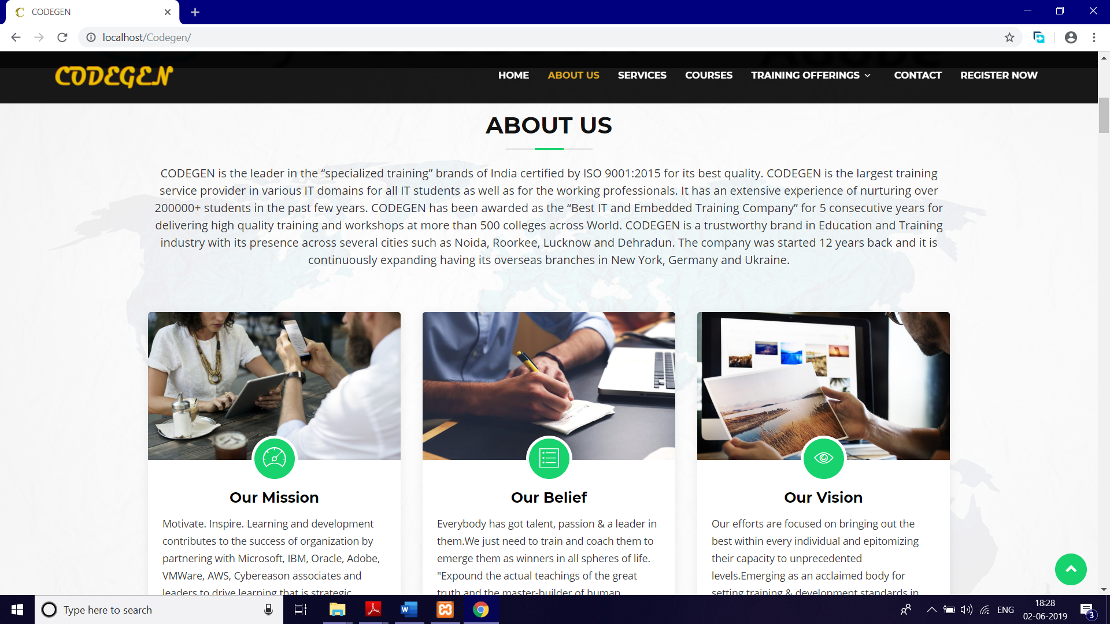

**7.1.3 Services:**

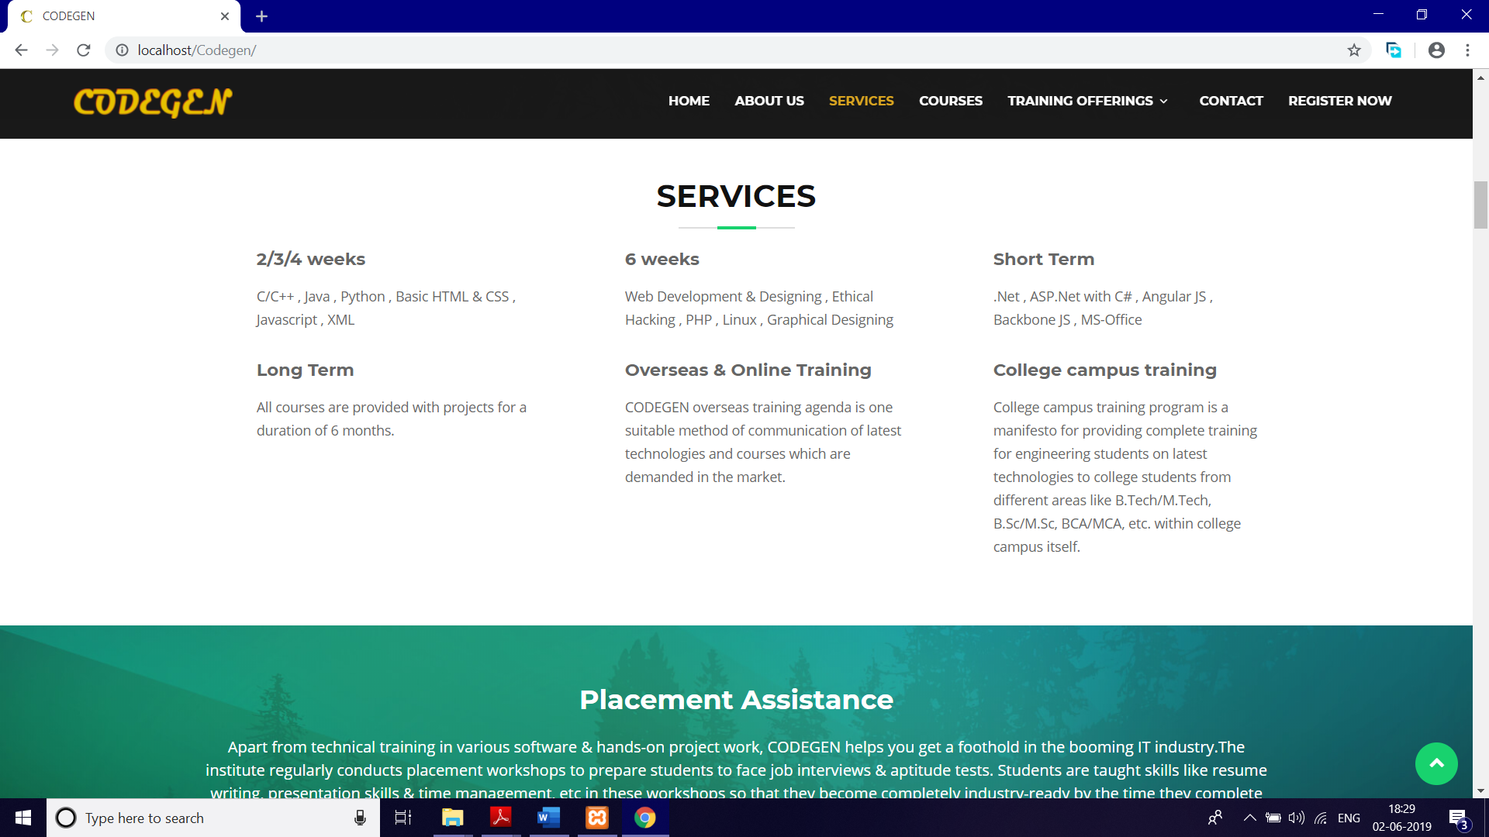

**7.1.4 Placement assistance**

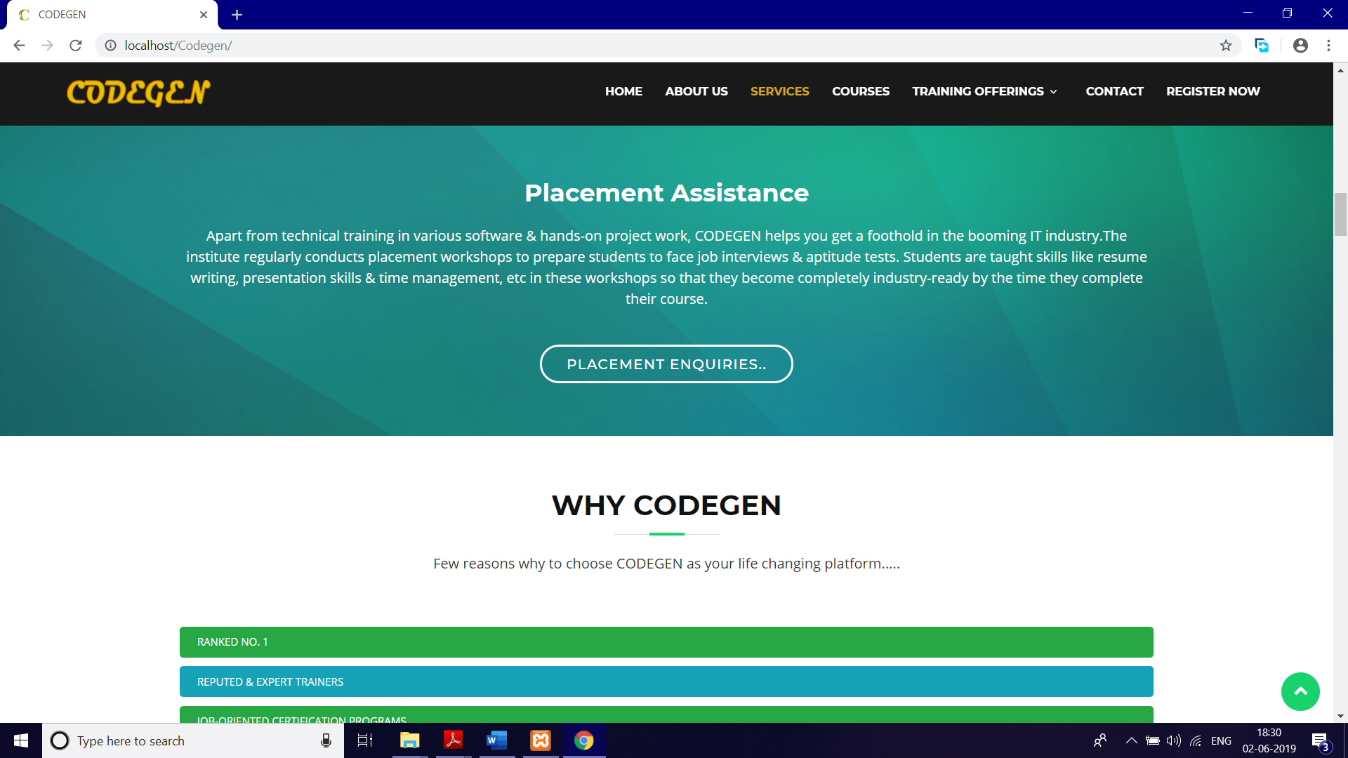

**7.1.5 Facts**

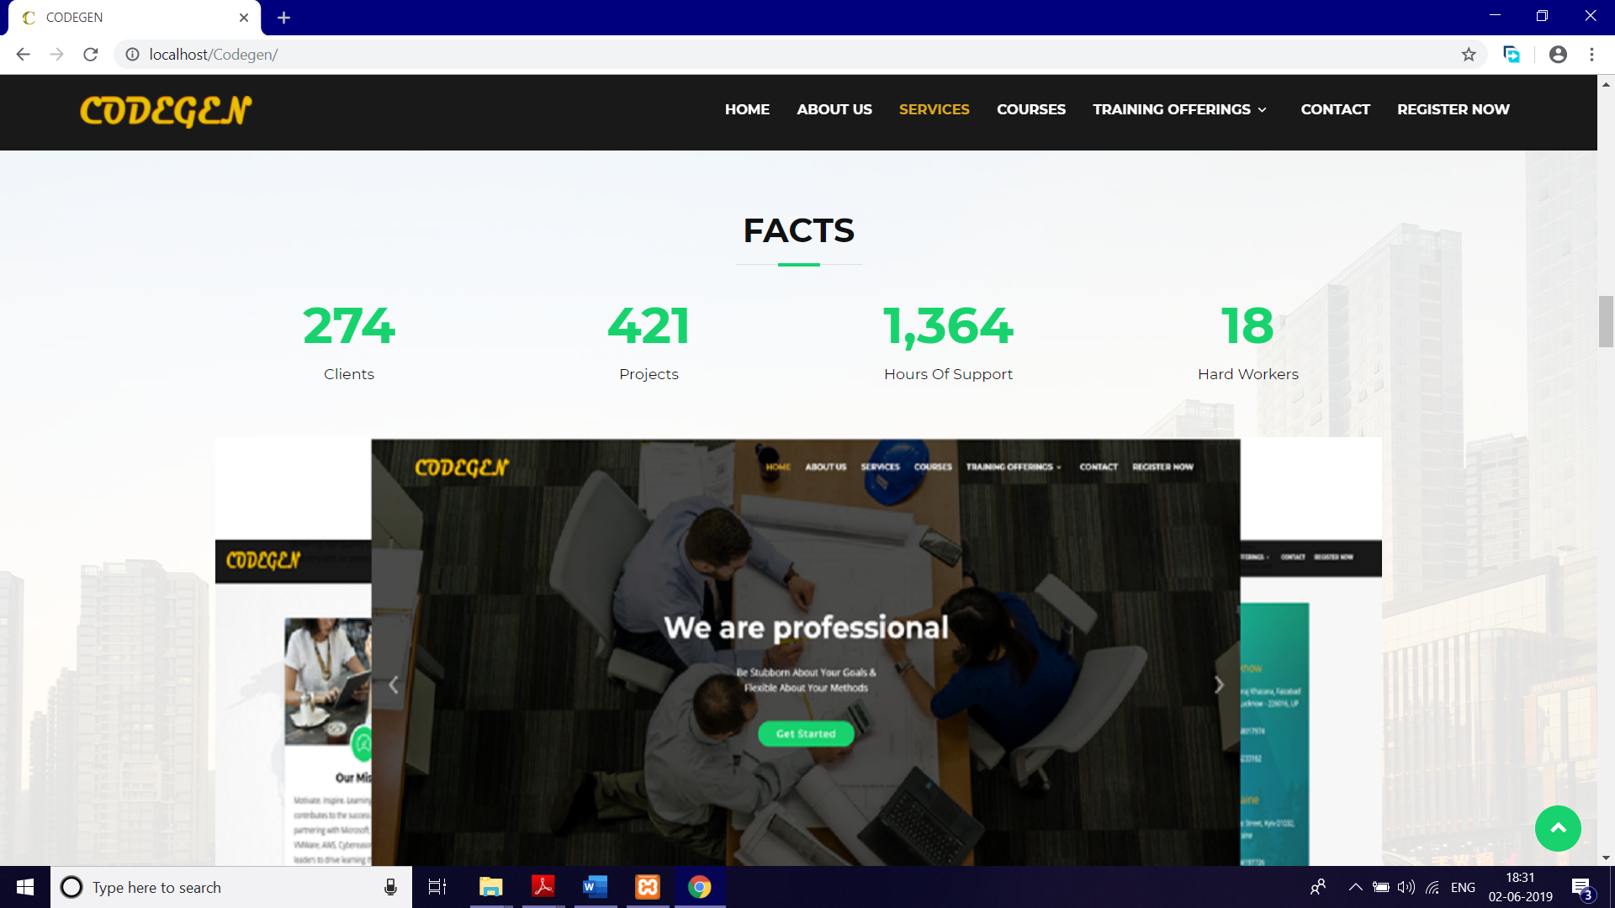

**7.1.6 Courses**

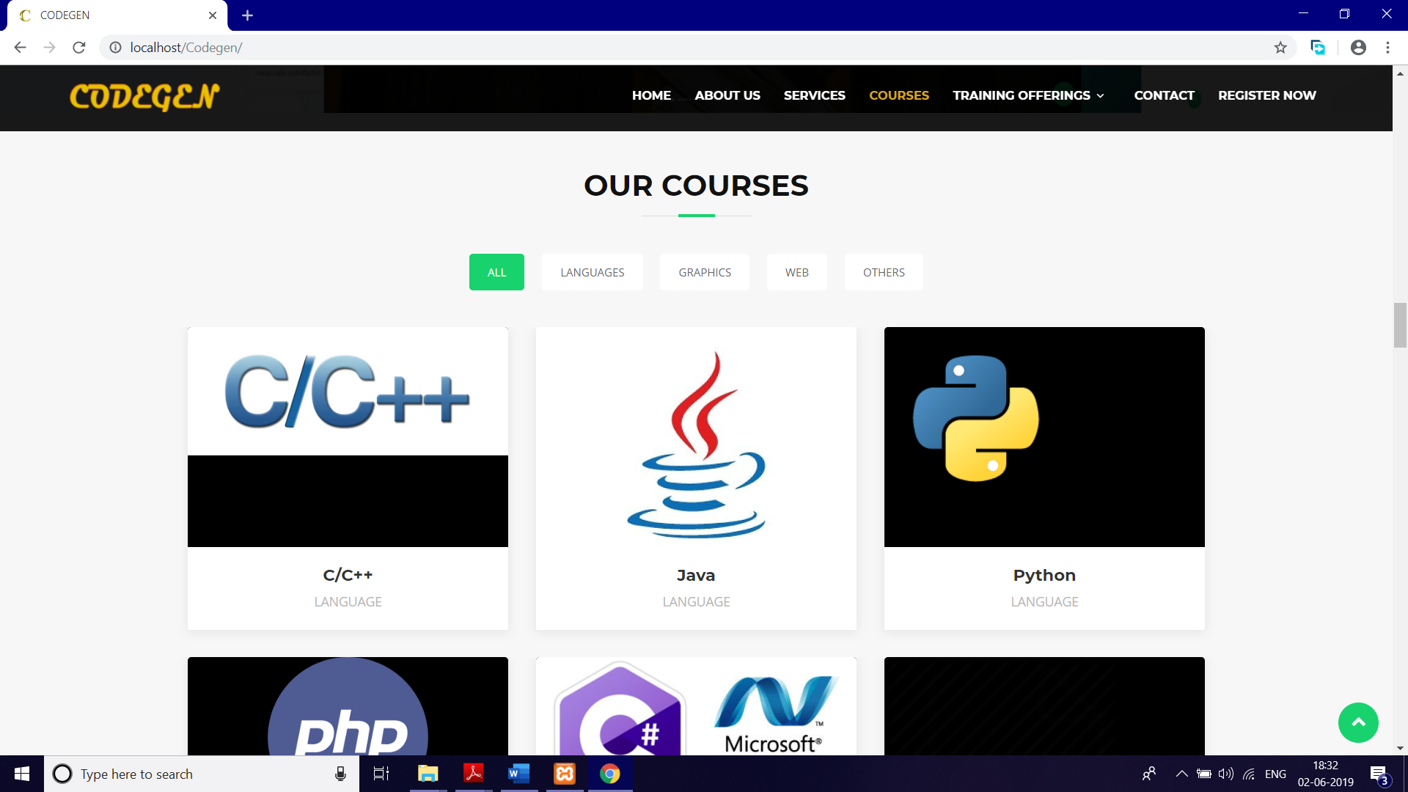

**7.1.7 Clients**

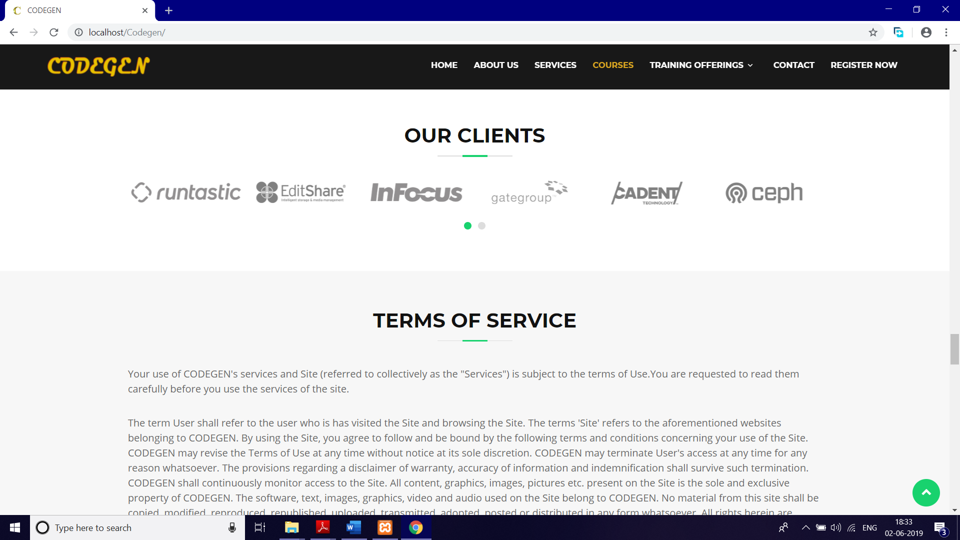

**7.1.8 Training & Offerings**

**7.1.8.1 Seminar**

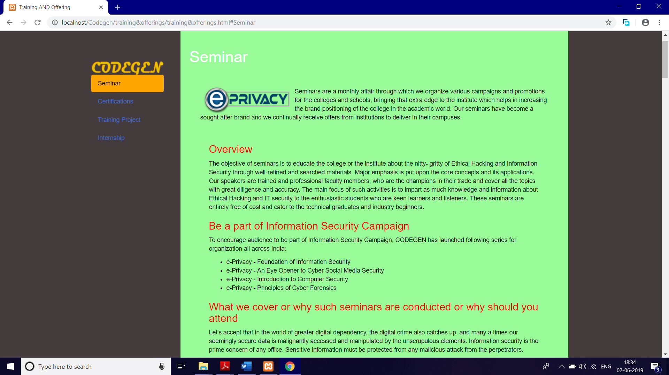

**7.1.8.2 Certifications**

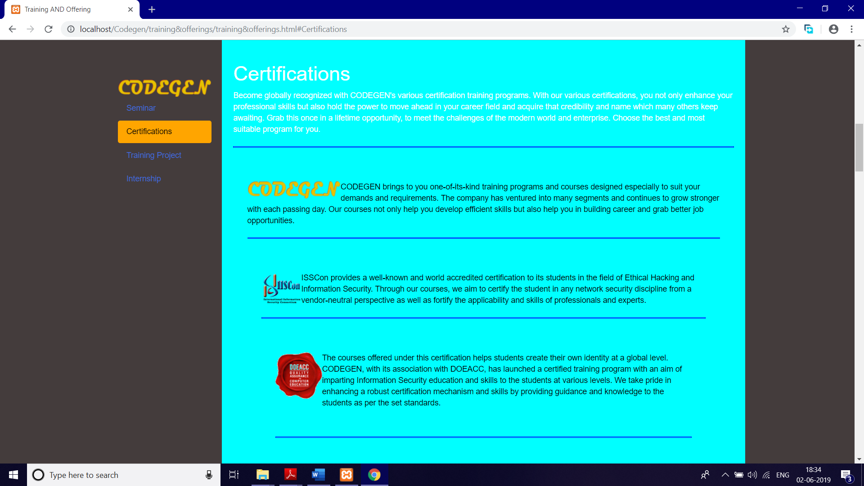

**7.1.8.3 Training Project**

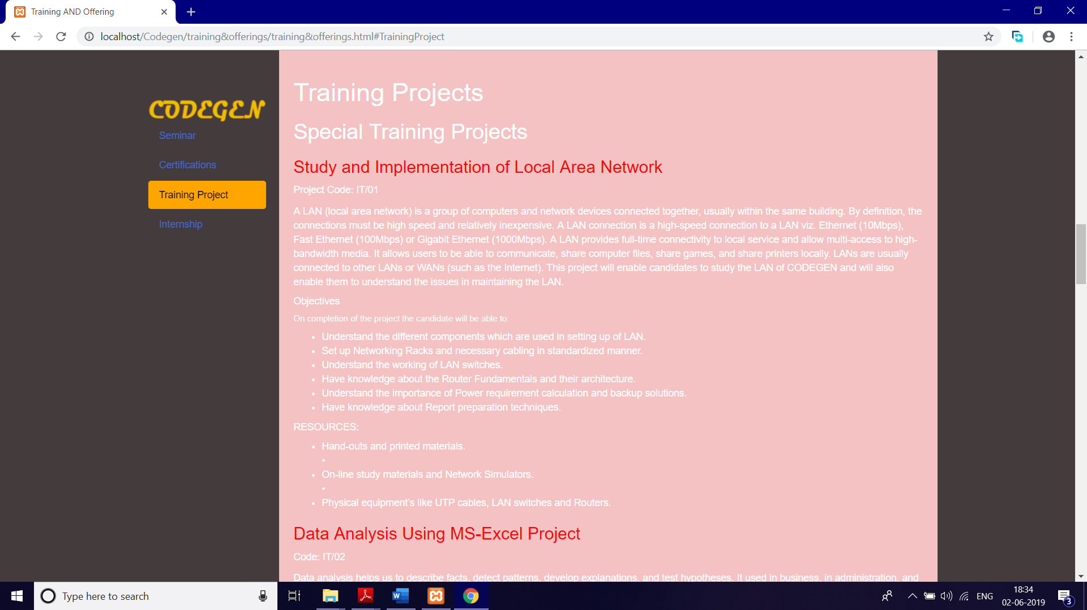

**7.1.8.4 Internship**

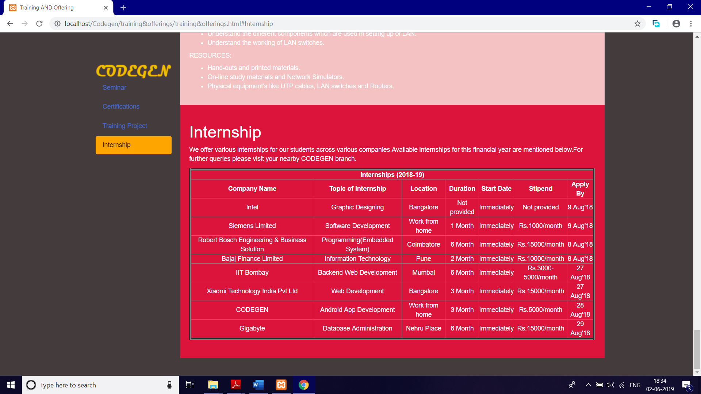

**7.1.9 Contact**

**7.1.9.1 Contact Us**

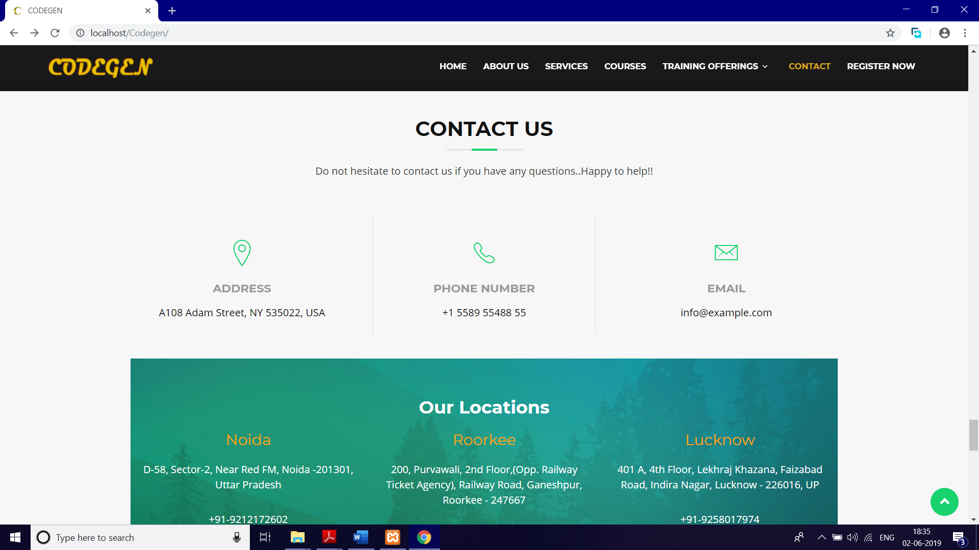

**7.1.9.2 Enquiry form**

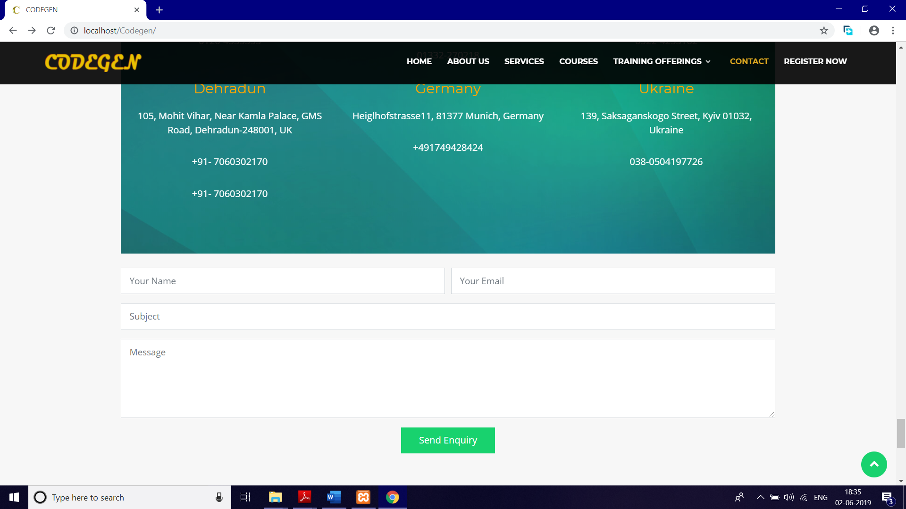

**7.1.10 Register Now**

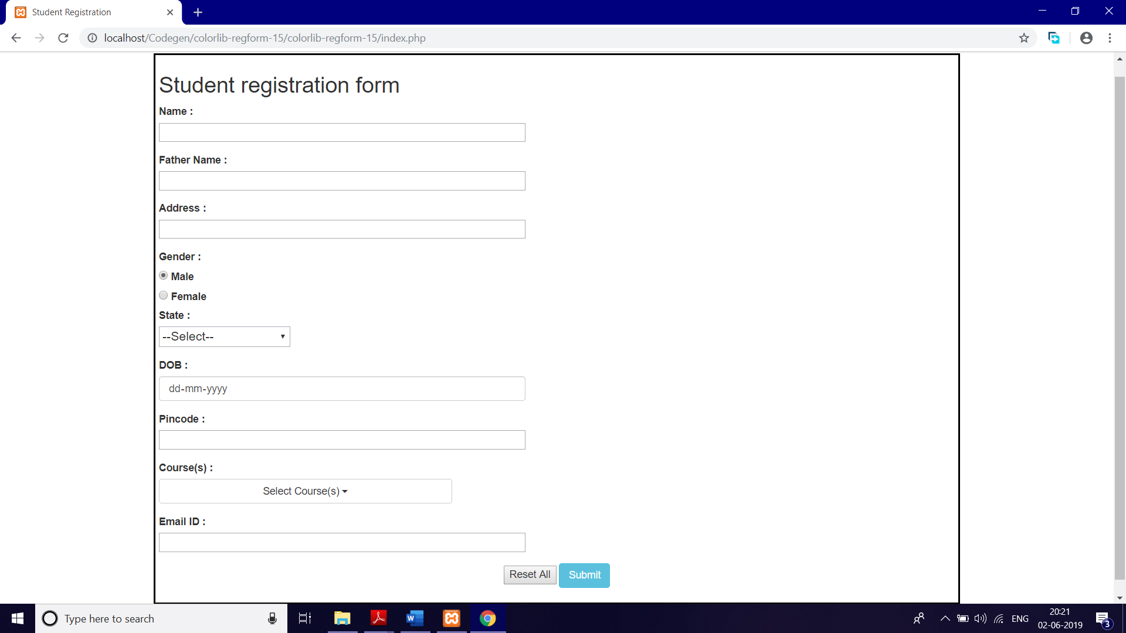

**7.2 CODEGEN App**

**System Testing and Implementation**

**8.1 Introduction**

Software testing is a critical element of Software quality assurance and represents the ultimate review of specification, design and coding. In fact, testing is the one step in the Software engineering process that could be viewed as destructive rather than constructive.

A strategy for Software testing integrates Software test case design methods into a well-planned series of steps that result in the successful construction of Software. Testing is the set of activities that can be planned in advance and conducted systematically. The underlying motivation of program testing is to affirm Software quality with methods that can economically and effectively apply to both strategic to both large and small-scale systems.

**8.2 Strategic approach to Software Testing**

The Software engineering process can be viewed as a spiral. Initially system engineering defines the role of Software and leads to Software requirement analysis where the information domain, functions, behaviour, performance, constraints and validation criteria for Software are established. Moving inward along the spiral, we come to design and finally to coding. To develop computer Software we spiral in along streamlines that decrease the level of abstraction on each turn.

A strategy for Software testing may also be viewed in the context of the spiral. Unit testing begins at the vertex of the spiral and concentrates on each unit of the Software as implemented in source code. Testing progress by moving outward along the spiral to integration testing, where the focus is on the design and the construction of the Software architecture. Talking another turn on outward on the spiral we encounter validation testing where requirements established as part of Software requirements analysis are validated against the Software that has been constructed. Finally we arrive at system testing, where the Software and other system elements are tested as a whole.

UNIT TESTING -------

------ MODULE TESTING -------

**Component Testing**

------ SUB-SYSTEM TESTING ---

**Integration Testing**

----- SYSTEM TESTING -----

**User Testing**

------ ACCEPTANCE TESTING

**8.3 Unit Testing**

Unit testing focuses verification effort on the smallest unit of Software design, the module. The unit testing we have is white box oriented and some modules the steps are conducted in parallel.

**8.3.1 White Box Testing**

This type of testing ensures that

* All independent paths have been exercised at least once
* All logical decisions have been exercised on their true and false sides
* All loops are executed at their boundaries and within their operational bounds
* All internal data structures have been exercised to assure their validity.

To follow the concept of white box testing we have tested each form .we have created independently to verify that Data flow is correct, All conditions are exercised to check their validity, All loops are executed on their boundaries.

**8.3.2 Basic Path Testing**

Established technique of flow graph with Cyclomatic complexity was used to derive test cases for all the functions. The main steps in deriving test cases were:

Use the design of the code and draw correspondent flow graph.

Determine the Cyclomatic complexity of resultant flow graph, using formula:

V(G)=E-N+2 or

V(G)=P+1 or

V(G)=Number Of Regions

Where V(G) is Cyclomatic complexity,

E is the number of edges,

N is the number of flow graph nodes,

P is the number of predicate nodes.

Determine the basis of set of linearly independent paths.

**8.3.3 CONDITIONAL TESTING**

In this part of the testing each of the conditions were tested to both true and false aspects. And all the resulting paths were tested. So that each path that may be generate on particular condition is traced to uncover any possible errors.

**8.3.4 DATA FLOW TESTING**

This type of testing selects the path of the program according to the location of definition and use of variables. This kind of testing was used only when some local variable were declared. The *definition-use chain* method was used in this type of testing. These were particularly useful in nested statements.

**8.3.5 LOOP TESTING**

In this type of testing all the loops are tested to all the limits possible. The following exercise was adopted for all loops:

* All the loops were tested at their limits, just above them and just below them.
* All the loops were skipped at least once.
* For nested loops test the inner most loop first and then work outwards.
* For concatenated loops the values of dependent loops were set with the help of connected loop.
* Unstructured loops were resolved into nested loops or concatenated loops and tested as above.

Each unit has been separately tested by the development team itself and all the input have been validated.

**System Security**

**9.1. Introduction**

The protection of computer based resources that includes hardware, Software, data, procedures and people against unauthorized use or natural

Disaster is known as System Security.

System Security can be divided into four related issues:

* Security
* Integrity
* Privacy
* Confidentiality

**SYSTEM SECURITY** refers to the technical innovations and procedures applied to the hardware and operation systems to protect against deliberate or accidental damage from a defined threat.

**DATA SECURITY** is the protection of data from loss, disclosure, modification and destruction.

**SYSTEM INTEGRITY** refers to the power functioning of hardware and programs, appropriate physical security and safety against external threats such as eavesdropping and wiretapping.

**PRIVACY** defines the rights of the user or organizations to determine what information they are willing to share with or accept from others and how the organization can be protected against unwelcome, unfair or excessive dissemination of information about it.

**CONFIDENTIALITY** is a special status given to sensitive information in a database to minimize the possible invasion of privacy. It is an attribute of information that characterizes its need for protection.

**9.2. Security In Software**

System security refers to various validations on data in form of checks and controls to avoid the system from failing. It is always important to ensure that only valid data is entered and only valid operations are performed on the system. The system employees two types of checks and controls:

**9.2.1 Client Side Validation**

Various client side validations are used to ensure on the client side that only valid data is entered. Client side validation saves server time and load to handle invalid data. Some checks imposed are:

* Validation is used to ensure those required fields are filled with suitable data only. Maximum lengths of the fields of the forms are appropriately defined.
* Forms cannot be submitted without filling up the mandatory data so that manual mistakes of submitting empty fields that are mandatory can be sorted out at the client side to save the server time and load.
* Tab-indexes are set according to the need and taking into account the ease of user while working with the system.

**9.2.2 Server Side Validation**

Some checks cannot be applied at client side. Server side checks are necessary to save the system from failing and intimating the user that some invalid operation has been performed or the performed operation is restricted. Some of the server side checks imposed is:

* Server side constraint has been imposed to check for the validity of primary key and foreign key. A primary key value cannot be duplicated. Any attempt to duplicate the primary value results into a message intimating the user about those values through the forms using foreign key can be updated only of the existing foreign key values.
* User is intimating through appropriate messages about the successful operations or exceptions occurring at server side.
* Various Access Control Mechanisms have been built so that one user may not agitate upon another. Access permissions to various types of users are controlled according to the organizational structure. Only permitted users can log on to the system and can have access according to their category. User- name, passwords and permissions are controlled o the server side.
* Using server side validation, constraints on several restricted operations are imposed.

**Conclusion**

This project developed, incorporated all the activities involved in the browsing centre.

It provides all necessary information to the management as well as the customer with the use of this system; the user can simply sit in front of the system and monitor all the activities without any physical movement of the file. Management can service the customer’s request best in time.

The system provides quickly and valuable information. These modules have been integrated for effective use of the management for future forecasting and for the current need.

The application demonstrates the way to develop an interactive web application or website by using interactive web client by using HTML, CSS, Bootstrap and jQuery with more secure way to access. This means the application server easily deployable and accessible.

**Scope for Future Development**

In today’s time everyone wants to be in their comfort zone and carry out whatever work they want to do, be it the registration for any course or for any placements.

So, to be able to cope up with the increasing demands of online applications and to make it easier for people to clarify their queries another important feature can be added i.e. the “live chat” feature and “live query processing systems”.

There is a saving time and saving of money in the use of web applications. If any country wants to work in the world market, it will have to improve the online web application services at international level because old traditional going to some place and then clarifying all the queries is not acceptable in the changing global market.

**Bibliography**

**12.1 For XAMPP installation**

* <https://www.wpblogx.com/install-xampp-on-windows/>

**12.2 For Android Studio installation**

* <https://developer.android.com/studio/install>

**12.3 For Notepad++ installation**

* <https://notepad-plus-plus.org/download/v7.7.html>
  1. **Reference websites**
* [www.w3schools.com](http://www.w3schools.com)
* [www.Bootstrapmade.com](http://www.Bootstrapmade.com)
* [www.wowslider.com](http://www.wowslider.com)
* www.weblesson.info
  1. **Reference Books**
* Web technology (DOEACC)